**FMG Pilot: Objections Module**

**Final Design Documentation_Rev0**

**PREPARED FOR:**

**Fortescue Metals Group**

Rebekah Jenaway – Manager of Projects and Access

Cara Librizzi – Senior Tenements Specialist

Michelle Bicanin – Senior Tenement Specialist

**PREPARED BY:**

PX4 Software  
November 2022

**Confidentiality**

This document was prepared for Fortescue Metals Group (**FMG**).

The information contained in this document is proprietary to PX4 Pty Ltd and PX4 Software Pty Ltd. This document is subject to copyright and is to be held in strict confidence and will not be disclosed, duplicated, or used, in whole or in part, for any purpose without prior written consent of PX4 Pty Ltd or PX4 Software Pty Ltd.

Every effort has been made to ensure the accuracy of the information contained in this document.

**Document** **Control**

All rights are strictly reserved. No part of this document may be reproduced in any form or by any means without prior written permission from PX4 Pty Ltd or PX4 Software Pty Ltd.

This document contains Confidential and Proprietary information to PX4 which is provided specifically for evaluation by FMG on the understanding that it is not to be disclosed to any third party except with PX4’s express permission.

**Note:** Any work not explicitly included in this document is implicitly excluded from the Project.

**Document History**

|  |  |  |  |  |
| --- | --- | --- | --- | --- |
| Document Author | Version | Release Date | Status | Comment |
| Toby Carrigan | RevA-V1 | 4 November 2022 | PX4 Approved | Submitted |
| Donna Gaffney | Rev0 | 25 November 2022 | PX4 Approved | Final |
|  |  |  |  |  |

**Table of Contents**

1 Final Design Documentation 7

1.1 Tenement Gateway 7

1.2 Main Menu and Header 7

1.3 Administration Portal 8

1.3.1 Update existing Groups and Escalation Process 9

1.3.2 Update existing Users and Permissions 10

1.3.3 GIS Connection 12

1.3.4 Managed Lists 13

1.3.5 Form Templates 18

1.3.6 Email Templates 20

1.3.7 Master Activity (Meta Data) Log 20

1.4 Process Maps 22

1.4.1 Outgoing (intersecting tenure) 22

1.4.2 Incoming (intersecting tenure) 24

1.4.3 Hearing Outcome 24

1.5 Authorities 25

1.5.1 Management Types 25

1.5.2 Update existing Authority List 26

1.5.3 Create Authority 26

1.5.4 Authority Objections 33

1.5.5 Dealings 35

1.6 Pre-objection Assessment 36

1.6.1 Assessment List 37

1.6.2 Assessment Detail 38

1.6.3 Assessment Complete 39

1.7 Create Objection 40

1.7.1 Outgoing Objection 40

1.7.2 Incoming Objection 42

1.8 Objections and Hearings List 44

1.8.1 Objection API 44

1.8.2 Objections List 45

1.8.3 Hearings API 48

1.8.4 Hearings List 49

1.9 Objection Console and Side Menu Options 50

1.9.1 Objection Console 50

1.9.2 Objection Detail 53

1.9.3 Objectors 56

1.9.4 Hearing History 57

1.9.5 Hearing Detail 57

1.9.6 Pending Actions 60

1.9.7 Related Agreements 61

1.9.8 Document Library 62

1.9.9 Completed Actions 62

1.9.10 Comment History 63

1.9.11 Change Log 63

1.10 Actions 64

1.11 ArcGIS Integration 69

1.11.1 Objection Console 69

1.11.2 Update existing Authority Console 69

1.12 Reporting 70

1.12.1 Excel Download 70

1.12.2 Standard Metric Graphs 70

1.12.3 Custom Reporting 75

1.13 Document Library 76

1.13.1 Document Library List 76

1.13.2 Update existing Attach Document 77

1.13.3 Update existing Document Details 78

1.14 Department Audit 79

1.15 Stakeholder Communications Module 81

1.15.1 Communication API 81

1.15.2 Communication List 81

1.15.3 Communication Console 82

1.15.4 Create Communication 84

1.15.5 Communication Detail 86

1.15.6 Other Related Entities 86

1.16 Notification Log 87

1.16.1 Browser Notification 88

1.16.2 Notification List 88

1.17 Stakeholders 89

1.17.1 Update existing Stakeholder Console 89

1.17.2 Update existing Stakeholder Detail 90

1.17.3 Stakeholder Objections List 91

1.18 Agreements 91

1.18.1 Update existing Agreement Console 91

1.18.2 Agreement Objections List 92

1.19 Private Cloud 92

# Final Design Documentation

PX4 Software will be creating a new optional Objection Module and Stakeholder Communication Module (Change Request CR-003) for our existing product PX4. These Modules are being designed, developed, and implemented specifically for FMG and FMG’s Objection obligations in Western Australia.

## Tenement Gateway

Department of Mines, Industry, Regulation and Safety (**DMIRS**) in Western Australia does not have a direct interface (**API**) to their publicly facing tenement database, Mineral Titles Online System (**eMITS**). Due to this limitation, the only way to get access to the data for direct importing into PX4, reporting on any updates and creating an auditable solution, is to create a background database. We are calling this database the ‘Tenement Gateway’.

Every night ALL pending and live mining and exploration tenements will be extracted from eMITS and saved into the Tenement Gateway.

FMG users will be able to quickly create a new Authority (tenure) in PX4 by importing the data directly from the Tenement Gateway. If the Authority is not administered by eMITS (eg Petroleum & Gas, Land Administration), FMG users will still be able to quickly manually create the Authority record.

Every night all Authorities (tenures) in PX4 will be compared against those in the Tenement Gateway and any updates will be logged and displayed in the new Department Audit list screen to allow the user to either ignore the change or to apply the change.

We also plan to expand the Tenement Gateway to also save publicly available data for all tenure types from all jurisdictions (eg Petroleum and Gas, and Land Administration) in the future.

## Main Menu and Header

The existing Main Menu and Header within PX4 will be rearranged with the additional functionality requested.

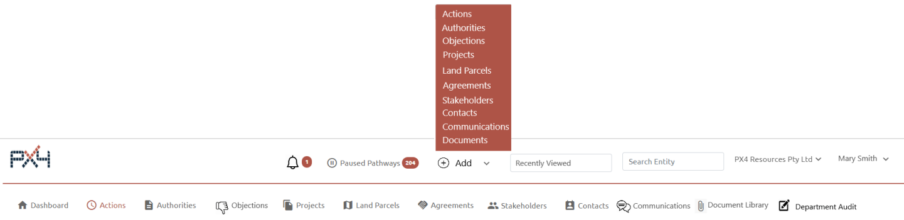

**Header**

* Search Entity moved from Main Menu
* Paused Pathways moved from Main Menu
* Remove all ADD entity buttons from the List screens and have one Add with a dropdown of all entity types, including new Objections and Communications
* New Notification icon, linked to new Notification list screen
* New Recently Viewed with dropdown of all entities previously viewed.

**Main Menu**

* New Objections, linked to the new Objections Module
* New Document Library, linked to the new full Document Library list screen
* New Communications, linked to the new Communication Module
* New Department Audit, linked to the new Department Audit list screen.

## Administration Portal

The PX4 Administration Portal is only available to users with Administrator permission. Users with Administration rights will be able to manage:

* Groups (teams)
* Escalation Process for pending statutory locked actions within each Group
* Users within each Group
* User Permissions for each User and Entity, including assigning additional Administrators
* GIS connection credentials
* Objection related dropdown list values
* Stakeholder Communication related dropdown list values
* Form templates
* Email templates.

Administrators will also be able to

* Delete Authorities
* View the Master Change Log for all Entities
* View the Master Activity Log for all input and output activity to PX4.

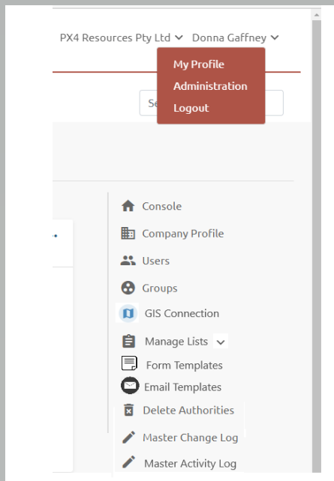

### Update existing Groups and Escalation Process

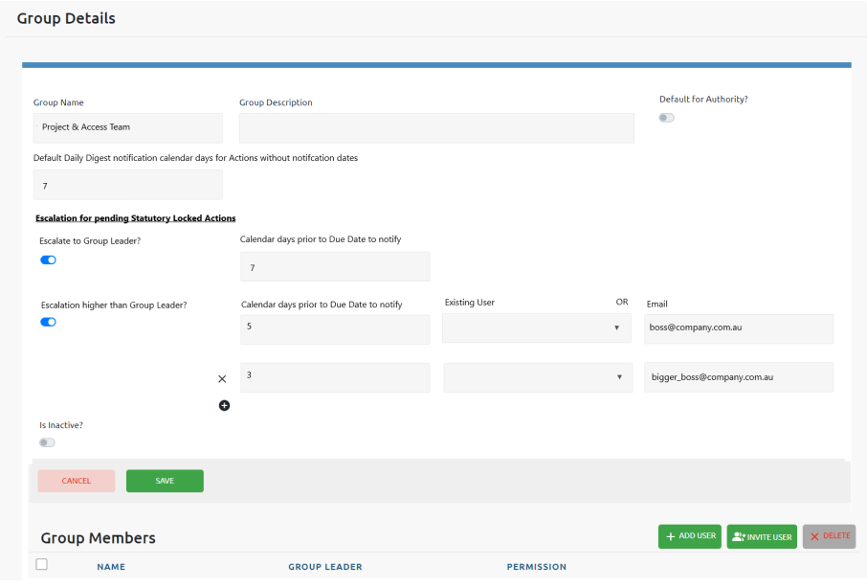

The Group Details screen will be expanded to include:

* Default Daily Digest notification calendar days for Actions without notification dates:
  + Currently user created Actions, as well as the Due Date, require 2 notification dates leading to the Due Date, for inclusion on the Daily Digest email
  + FMG has requested the notification dates be optional
  + If an Action is created without notification dates, this field will be the default notification timeframe.
* FMG has requested an Escalation process for pending Statutory Locked Actions
  + Option to escalate to the Group Leader
    - Notified via Push Notification and optional Daily Digest email is preferred
  + Option to escalate to higher than Group Leader, with the ability to nominate multiple assignees The nominee can be:
    - An internal PX4 registered user (notified via Push Notification and optional Daily Digest email if preferred); or
    - An external email address (notified via email).

### Update existing Users and Permissions

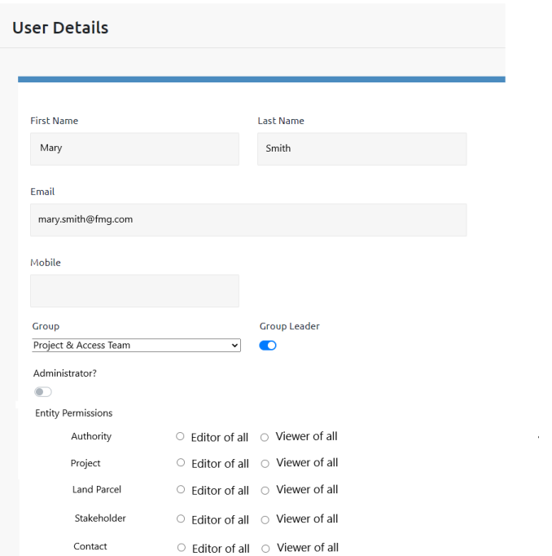

The User Detail screen will be expanded to include:

* An ability for Users to decides to receive their notifications via the Daily Digest email rather than push notifications as they are not in PX4 regularly enough
* Advanced User Permissions.

Currently in PX4, Users belong to one Group. Each Group has one nominated Group Leader. Each User can access all data in all Groups. Each User is defined as:

* Administrator
  + Access to the Administration Portal
  + Ability to create, edit and delete all records (including authorities).
* Editor
  + Ability to create, edit and delete all records, with the exception of Authorities.
* Viewer
  + Read all records but cannot update or modify any record.

PX4 proposed 3 User permission options for FMG:

* Basic user permissions
* Advanced user permissions
* Role based access control (**RBAC**).

Via Change Request CR-013, FMG has chosen Advanced User Permissions (for the Objections and Agreements Entities within PX4). If the User is not an Administrator:

* For each base Entity Type (Authority, Project, Land Parcel, Stakeholder, Contact)
  + Each User is defined as either:
    - Editor
    - Viewer.
* For the new Objections entity:
  + Each User can be given:
    - Editor access to all objection data
    - Viewer access to all objection data
    - No access to any objection data
    - Restricted access to objection data
    - Editor or Viewer access to:
      * Specific Jurisdictions
      * Specific Objection Categories (eg *Mining Act 1978*, *Native Title Act 1993*)
      * Specific Management Groups
      * Specific Groups
      * Specific Users
      * Documents, including confidential Documents.
* For the Agreements entity
  + Each User can be given
    - Editor access to all agreement data
    - Viewer access to all agreement data
    - No access to any agreement data
    - Restricted access to agreement data
    - Editor or Viewer access to
      * Specific Agreement Categories (eg Indigenous, Land Access, Commercial)
      * Specific Management Groups
      * Specific Groups
      * Specific Users
      * Documents, including confidential Documents
      * Non-Payment Actions
      * Payment Actions.

A User will only be able to access data for which they have been given Editor or Viewer access.

### GIS Connection

FMG maintain their own spatial database using ArcGIS. They have requested all GIS map connections use their spatial database, with an option to also connect to the Department’s spatial database (**TENGRAPH**).

For PX4 to automatically connect to a customer’s spatial database, the connection credentials and layer details will be required to be provided to PX4, on the understanding access will be administered by the customer’s database administrator.

PX4 can connect to spatial data via an API connection, which will be developed to ensure the PX4 platform connects to FMG’s mapping system.

### Managed Lists

FMG has requested administrator control over all drop-down lists.

However, the administration of lists, headed as follows, must remain under PX4 control as they are required for the pathway workflows and actions:

* WA Authority Types (can be expanded to include other tenure types not in WA’s eMITS (eg Petroleum & Gas and Land Administration):
  + Mineral or Coal:
    - E - Exploration Licence
    - E - Exploration Licence (pre 10 February 2006)
    - P - Prospecting Licence
    - R - Retention Licence
    - M - Mining Lease.
    - L - Miscellaneous Licence
    - L - Miscellaneous Licence (linked)
    - G - General Purpose Lease
    - G - General Purpose Lease (linked)
    - AL – Miscellaneous Licence S.A
    - ML – Mineral Lease
    - MC – Mineral Claim
  + Miscellaneous:
    - Generic licence / permit – no expiry
    - Generic licence / permit – expiry
    - Generic licence / permit – renewal
  + Petroleum and Gas:
    - PEL – Petroleum Exploration Licence
    - PL – Petroleum Licence
  + Land Administration:
    - LA – Pastoral Lease
    - LA – Special Lease
    - LA – General Lease
    - LA – Easement
    - LA – Diversification Lease
    - LA - File Notation Area (FNA)
    - LA – Section 91 Licence
    - LA – Section 182 Licence
    - LA – Reserve
    - LA – Private Land
    - LA – Local Government Authority
  + Native Title:
    - Native Title Claim
    - Native Title Determination.
* Agreement Types:
  + Land Access:
    - Conduct and Compensation Agreement
    - Deferral Agreement
    - Opt Out Agreement
    - Waiver of Entry Notice
    - Compensation Agreement
    - General Land Access Agreement
    - Woomera Prohibited Area Agreement
    - Work Area Clearance Agreement
    - Access Agreement
    - Deed of Variation
    - Deed of Covenant
    - Deed of Assignment and Assumption.
  + Commercial:
    - General Commercial Agreement
    - Joint Venture Agreement
    - Farm In / Farm Out Agreement
    - Option Agreement
    - Memorandum of Understanding
    - Lease Agreement
    - Royalty Agreement
    - Sale Agreement.
  + Indigenous:
    - Indigenous Land Use Agreement (**ILUA**)
    - Expedited Procedures – Ancillary Agreement
    - Right to Negotiate Agreement (**RTN**)
    - Part 9B Agreement
    - Section 31 Agreement
    - Supplementary Agreement (top up)
    - Cultural Heritage Agreement
    - Cultural Heritage Management Plan
    - Deed of Assumption
    - Deed of Exploration (land rights) for access
    - Claim-wide Agreement
    - General Indigenous Agreement
    - Private Indigenous land use agreement (**ILUA**)
    - Public Indigenous land use agreement (**ILUA**)
    - Ancillary Agreement
    - Heritage Protection Agreement.
* WA Objection Types:
  + *Mining Act 1978*:
    - Outgoing Objection (intersecting tenure)
    - Incoming Objection (intersecting tenure).
* Action Types:
  + Agreement
  + Amendment
  + Application
  + Commence Renewal
  + Disturbance and Rehabilitation
  + Exemption
  + Follow-up
  + Fossicking
  + Land Access
  + Native Title
  + Notify
  + Objection
  + Objection Administration
  + Other
  + Payment
  + Pre-Objection Assessment
  + Public Liability
  + Public Liability Payment
  + Reduction
  + Relinquishment
  + Reminder
  + Renewal
  + Rent/Fee Payment
  + Report
  + Return
  + Royalty Payment
  + S&H Return
  + Variation.
* Hearing Types:
  + Mention
  + Trial.

The following drop-down lists will remain under PX4 control, but we can look at allowing User control in the future. Releasing the following drop-down lists to User control will impact ALL PX4’s existing clients by duplicating existing entries into each client’s environment and retagging their existing documents:

* Land Parcel Types:
  + Easement
  + Freehold
  + Leasehold
  + Other
  + Pastoral Holding – freehold
  + Pastoral Holding – leasehold
  + Rail Corridor
  + Reserve
  + Road Corridor
  + Unallocated State Land
  + Unidentified
  + Water Feature.
* Stakeholder Roles:
  + Authority holder
  + Commonwealth department
  + Consent authority
  + Easement holder
  + Fossicking permit holder
  + Indigenous Peoples
  + Indigenous representative
  + Landholder / Owner
  + Lessee
  + Local council
  + Management grouping
  + Objector
  + Occupier / Tenant
  + Overlapping authority holder
  + Parent company
  + Real estate agent
  + State department
  + Subsidiary company
  + Utility.
* Document Category Tags:
  + Agreement
  + Annual Report
  + Application
  + Approval
  + Contact Card
  + Contract
  + Court Document
  + Disturbance
  + Entry Notice
  + Exploration Program
  + External Correspondence – incoming
  + External Correspondence – outgoing
  + Internal Correspondence
  + Internal Document
  + Invoice
  + Map
  + Mining Plan
  + Note
  + Operations Report
  + Other
  + Plan
  + Programming Directions
  + Purchase Order
  + Receipt
  + Rehabilitation
  + Summary
  + Title.

The Managed Lists in the Administration Portal, will allow the administrator to:

* Create new entries in the lists
* Edit existing entries in the lists (if an entry is already in use, a message will be displayed before changing the description)
* Delete existing entries in the list, if not in use.

The following new Objection and Communication related drop-down lists will be client-controlled, and pre-loaded with values.

#### Objection Manager

This will link to the list of active Users:

* Allana Coumbe
* Cara Librizzi
* Denice Johns
* Fiona Snellin
* Jessica Davies
* Jade Dos Ramos
* Kayleigh Carpenter
* Megan Menon
* Michelle Bicanin
* Moira Nell
* Rebekah Jenaway
* Ryan Jones
* Sarah Framjee.

#### Internal Legal Representative

This will link to the list of active Users:

* Alastair McLachlan
* Aimee Jones
* Hamish Robertson
* Stuart Robinson.

#### Objection Priority

Each priority will be given a traffic light colour:

* Medium (amber)
* High (red).

#### Objection Internal Status

* Recorded
* MOPD Lodged
* To be Withdrawn
* Particulars
* Evidence
* Trial
* Other legislation
* Sine Die
* Blue Ribbon
* True Fella
* F&F
* Other Legislation.

#### Objection Negotiation Status

* Not commenced
* Third Party – 1st draft
* FMG – 1st draft
* FMG Access Team – Review
* FMG Legal Team – Review
* FMG External Counsel – Review
* Third Party – Review
* Access Agreement Finalised
* FMG – Execution
* Third Party – Execution
* Dispute
* Excision of Overlap
* Pastoral team managing.

#### Objection Resolution Status

* Unknown
* 3rd Party Objection withdrawn
* 3rd Party tenure withdrawn
* Rejected / Error
* FMG objection withdrawn
* FMG tenure withdrawn
* Resolved by Access Agreement
* Resolved by Minute (Conditions)
* Excision of overlap.

#### Grounds for Objection

* Standard
* Standard - L1SA
* Standard - IB Operations
* Standard - Pilbara Water and Power
* Non-Standard.

#### Hearing Location

* Central Law Courts, Perth
* Mount Magnet Warden’s Court
* Meekatharra Courthouse
* Kalgoorlie Warden’s Court
* Leonora Warden’s Court
* Southern Cross Warden’s Court
* Cue Courthouse
* Supreme Court (WA)
* High Court of Australia.

#### Communication Category

* Complaint
* Objection.

#### Communication Type

* Email in
* Email out
* In person
* Phone call in
* Phone call out
* Meeting
* Letter
* Teams / Online
* Other.

### Form Templates

FMG require the ability to automatically create pre-filled forms using data within PX4.

PX4 use the reporting template platform <https://www.reporting.cloud> to create the Word templates. An Objections API will be created to allow the form generation to occur.

We will create 3 form templates in reporting.cloud:

* Letter of Service
* Affidavit of Service
* Minute of withdrawal of objection.

Once the templates have been created, within the Administration Portal, the Administrator can give the template a name and connect to reporting.cloud platform using the API key.

The Letter of Service form requires a Registered Post Number to be captured and included on the form upon creation.

### Email Templates

Via Change Request CR-010, FMG require the ability to quickly create emails using email templates, attaching a spreadsheet of basic selected Objection data.

We will create 1 email template:

* Engaging External Legal Representative.

One (1) email will be generated for multiple Objections selected and displayed for review and possible amendment.

The email template could include mail-merge fields.

An example of the email template will be:

Dear [External Legal Rep]

Fortescue Metals Group Ltd requests the engagement of [External Legal Rep] to act on its behalf in in relation to the attached objections.

Please provide your reference numbers in response to this email and direct any future queries to the appointed P&A Objection Manager.

Kind regards

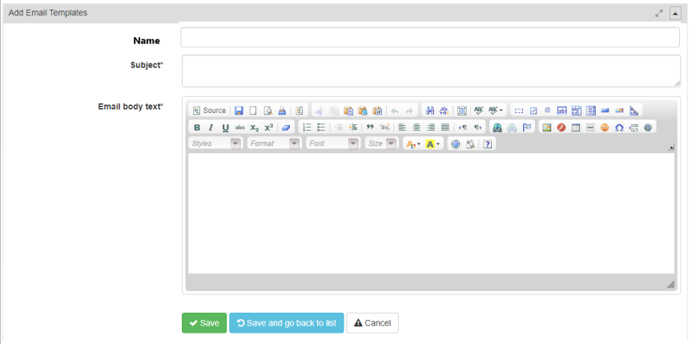

### Master Activity (Meta Data) Log

All changes (create, update, delete) to data within PX4 will be logged in the **Master Change Log** along with who made the update and when.

All notifications triggered within PX4 will be logged in the new **Notifications** **Log** along with who triggered the notification and when.

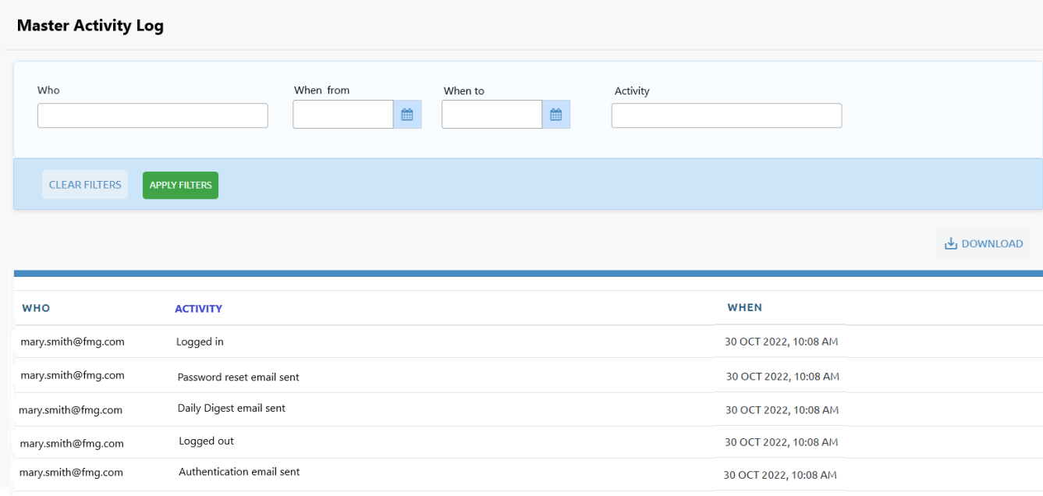

Via Change Request CR-008, FMG has also requested a log of all User inputs and outputs to the PX4 platform in the **Master Activity Log**. This will include:

* User log in
* User log out
* Emails sent to Users:
  + Password resets
  + Daily Digest
  + Authentication.
* Forms created from templates and downloaded
* Emails created from templates (not sent) and displayed for review.

The list can be filtered by:

* Who (email address)
* When from date
* When to date
* Activity (text matching).

The displayed list can be downloaded to Excel.

## Process Maps

### Outgoing (intersecting tenure)

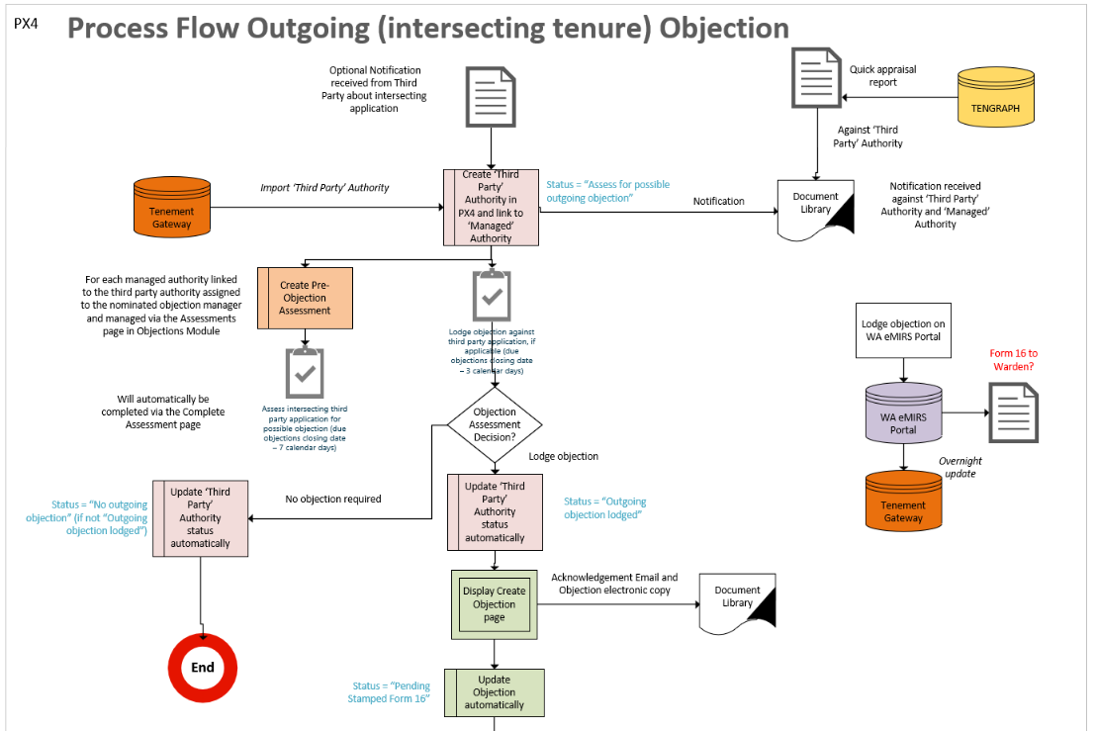

### Incoming (intersecting tenure)

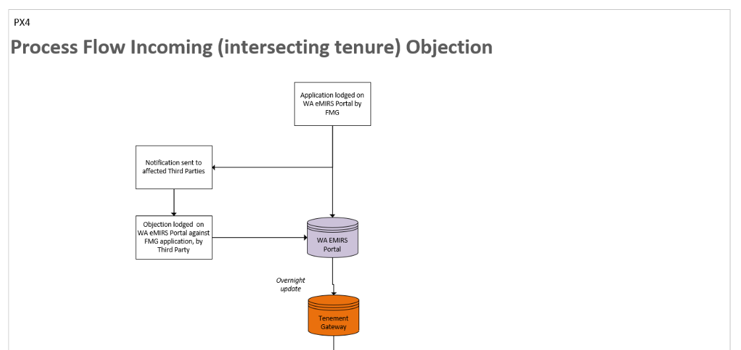

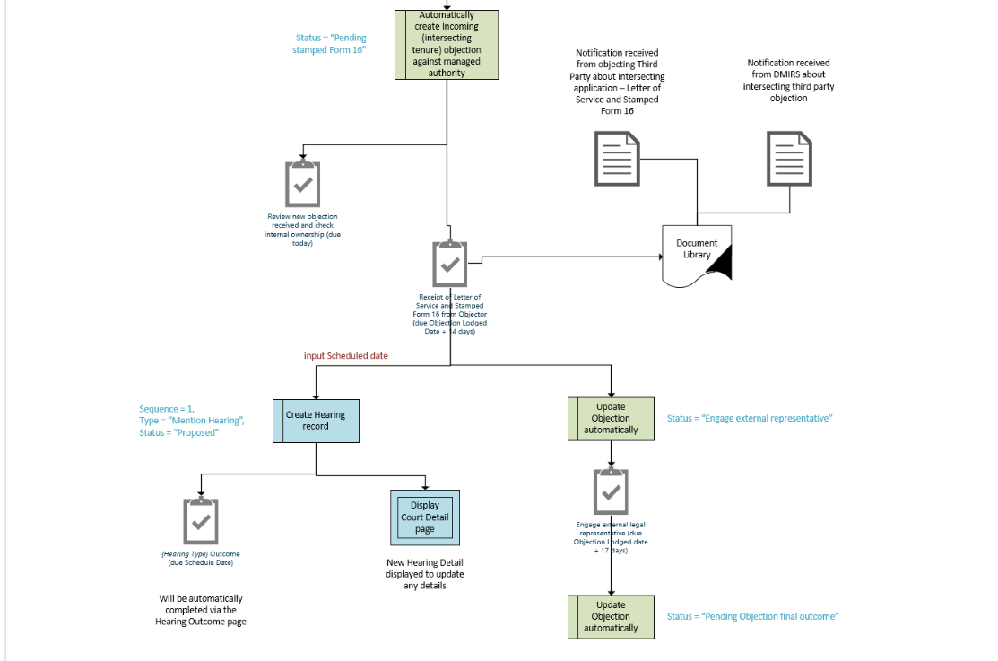

### Hearing Outcome

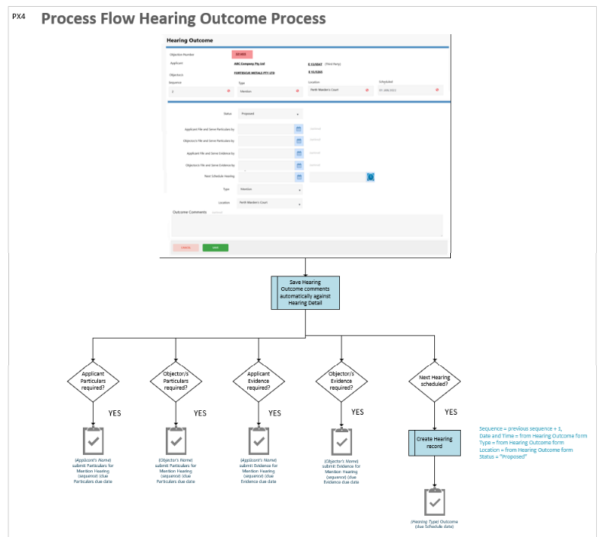

## Authorities



In PX4 we refer to tenements, leases, permits, licences, certificates, approvals, consents, and so on using the broad label of *Authority*.

### Management Types

#### Managed Authorities

Currently in PX4 all Authorities are tenement managed.

Tenement management actions are out of scope for this Objections Module pilot. Rather than stopping the tenement management actions being created, PX4 will not display them, except for the Renewal Due action. The managed authority will still need to be kept Live and Current, if applicable.

The User’s subscription record will indicate if tenement-related information is to be displayed or not. This affects the Daily Digest email, Actions list screen, Pending Actions card on the Authority Console and Authority Pending Actions screen.

#### Third Party Authorities

Another Authority Management Type will be required to indicate Third Party Authorities. That is those tenements owned and managed by non-FMG entities, but a record is required to link incoming and outgoing Objections.

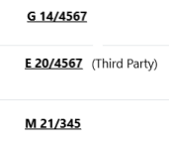

When viewing Authority numbers on all screens and reports, to easily differentiate if the Authority is managed or third party, all Third-Party Authorities will have ‘(Third Party)’ after the number.

The available Authority Category and Authority Types will be expanded, for Third Party Authorities only, to include:

* Petroleum & Gas:
  + Exploration Permit
  + Petroleum Lease
  + Production Licence
  + Pipeline Licence
  + Retention Lease.
* Land Administration:
  + Reserve Lease
  + Road Lease
  + General Lease
  + Purchase Lease
  + Aboriginal Lease
  + Subdivisional Lease
  + Government Agency Lease
  + Pastoral Lease
  + Acquisition Lease.

### Update existing Authority List

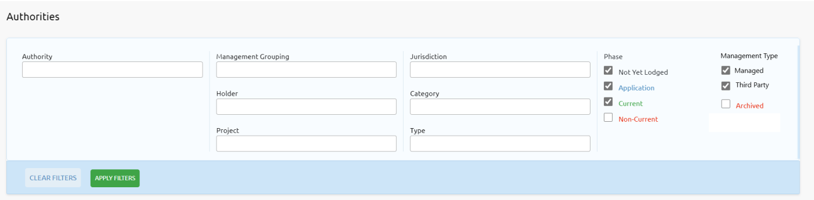

The Authority list screen will be amended to allow the filtering of Managed and / or Third-Party Authorities.

### Create Authority

WA eMITS tenements can be imported immediately from the Tenement Gateway. Other WA tenure types and other jurisdictions can be manually created.

Click Add > Authority from the Header.

#### Import Managed Authority

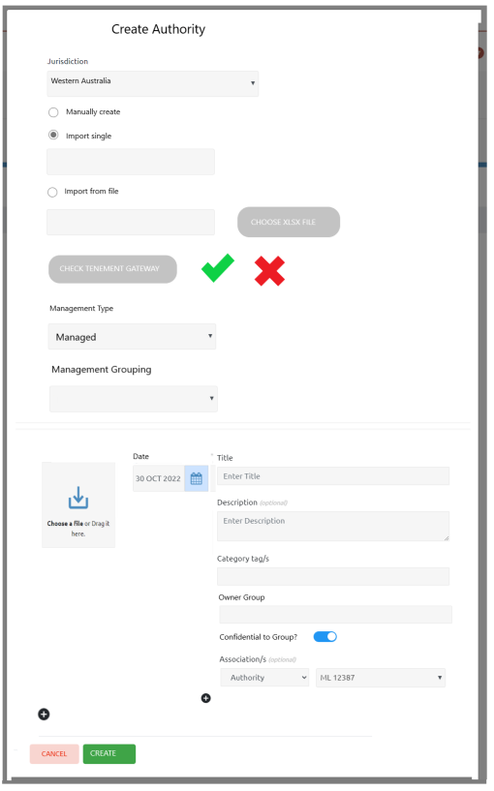

Managed Authorities can be imported individually or from a file. The file will be a one column spreadsheet of tenement numbers.

After checking the tenement number/s exist in the Tenement Gateway, choose ‘Managed’ Management Type, Management Grouping and attach optional document/s, click CREATE button.

This will create a Managed Authority with no tenement management actions, except the Renewal Due action.

#### Manually create Managed Authority

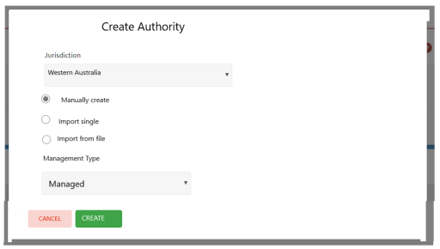

Choose Jurisdiction, Manually create and Management Type of ‘Managed’. Click the CREATE button.

This will display the existing Create Authority screen for manual entry. *This screen is currently used by all of our existing customers.*

#### Import Third Party Authority (for Outgoing Objection)

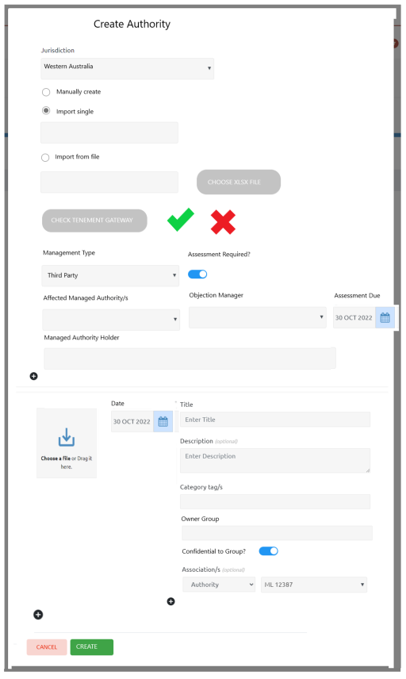

Third Party Authorities can be imported individually only.

After checking the tenement number/s exist in the Tenement Gateway, choose ‘Third Party’ Management Type and whether an Assessment is required prior to lodging an Objection. Toggle Yes, for outgoing objections.

Choose the Managed Authority/s affected by this Third-Party Authority and if assessment is required, choose the Objection Manager and when assessment is required, ‘Assessment Due’.

When a Managed Authority is chosen, the current Holder/s for the Authority will be displayed underneath. Multiple Managed Authorities affected by this Third-Party Authority can be chosen.

Optional documents can be linked to the Third-Party Authority and Managed Authorities (the associations will be automatically established).

Click CREATE button, to automatically create the Third-Party Authority record, link to the Managed Authority records, create the Pre-Objection Assessment record if Assessment is required and initiate the pathway to determine if an objection is required or not.

#### Import Third Party Authority (for Incoming Objection)

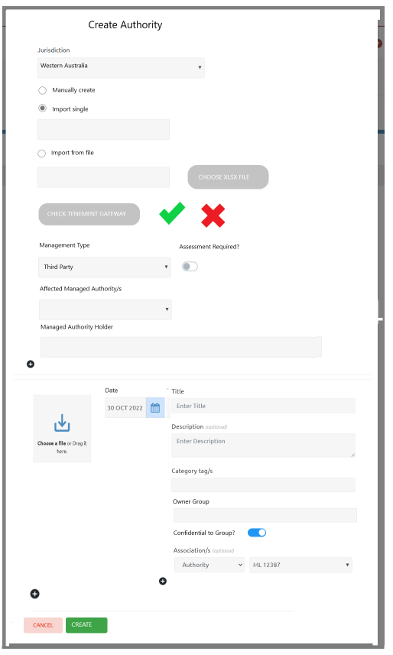

Third Party Authorities can be imported individually only.

After checking the tenure number/s exist in the Tenement Gateway, choose ‘Third Party’ Management Type and whether an Assessment is required prior to lodging an Objection. Toggle No, for incoming objection.

Choose the Managed Authority/s affected by this Third-Party Authority. The current Holder/s for the Authority will be displayed underneath. Multiple Managed Authorities can be affected by this Third-Party Authority and can be chosen.

Optional documents can be linked to the Third-Party Authority and Managed Authorities (the associations will be automatically established).

Click CREATE button, to automatically create the Third-Party Authority record and link to the Managed Authority records.

#### Manually create Third Party Authority

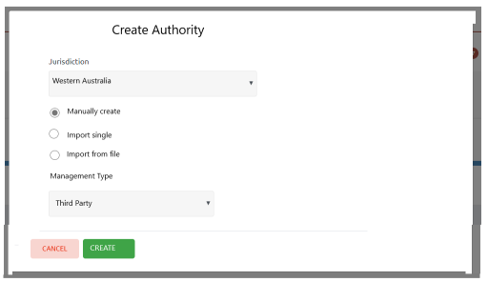

Choose Jurisdiction, Manually create and Management Type of ‘Third Party’. Click CREATE button.

This will display the new Create Third Party Authority screen.

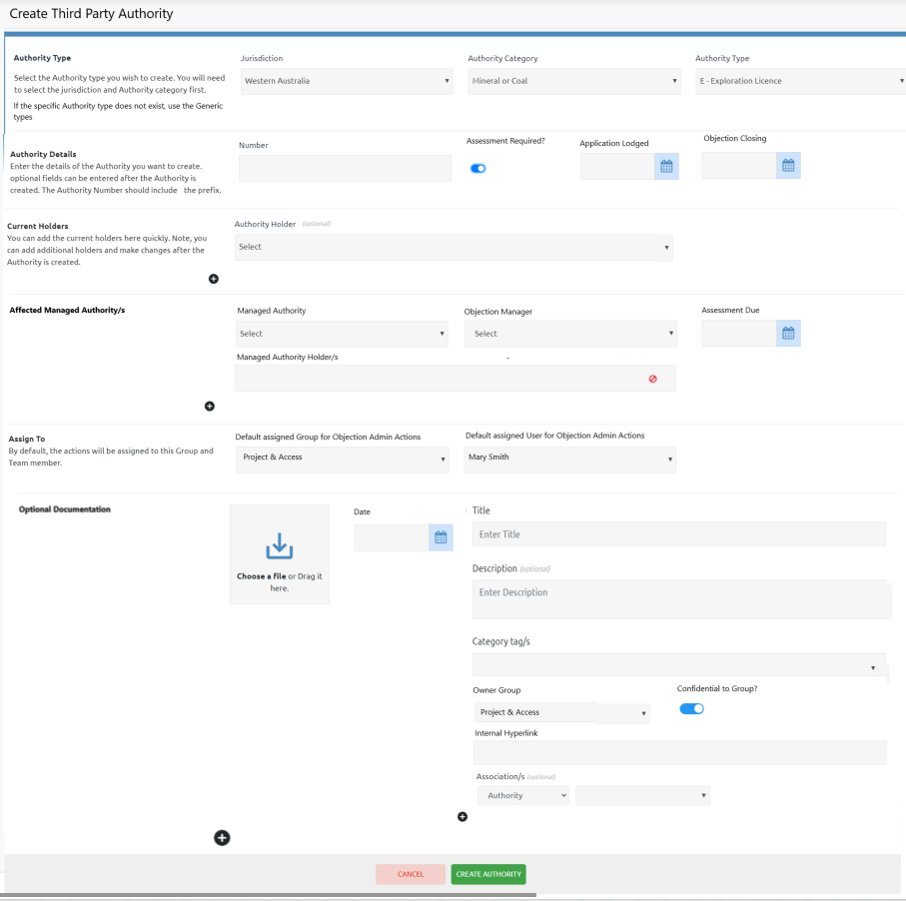

**Jurisdiction** – defaults to Western Australia.

**Authority Category** – tenure type groups (eg Mineral or Coal, Miscellaneous, Petroleum & Gas, Land Administration).

**Authority Type** – type of tenement (managed by PX4 Studio).

**Number** – tenement number, must not already exist in PX4.

**Assessment Required?**

* If this Third-Party Authority is for a possible outgoing objection, activate the toggle.
  + **Application Lodged** – Third Party application lodged date
  + **Objection Closing** – date objections to the Third-Party application close
  + **Objection Manager** – drop down list of FMG managed Objection Managers for each Managed Authority (see Managed Lists)
  + **Assessment Due** – date pre-objection assessment decision of the Managed Authority is required.
* If this Third-Party Authority is for an incoming objection, deactivate the toggle
  + Application Lodged, Objection Closing, Objection Manager and Assessment Due will not be displayed.

**Current Holder/s** – Third Party Holder Stakeholder, can be multiple.

**Affected Managed Authority/s** – Managed Authority affected by the Third-Party Authority, can be multiple.

**Managed Authority Holder/s** – once the Managed Authority is selected, the current holder/s for the Authority will be displayed. The current Holders for Authorities are updated from the Authority Console for the Managed Authority.

**Assigned To** – The default User for Objection Administration Actions created against this Third-Party Authority.

**Optional Document/s** – Attach one or more documents, which will be automatically associated with the Third-Party Authority and Managed Authority/s.

**CREATE AUTHORITY button**

* New Authority record created with a Management Type of ‘Third Party’
* If Assessment Required Toggle Yes:
  + Automatically creates a separate Pre-Objection Assessment record against the Third-Party Authority for EACH Managed Authority, assigned to the Objection Manager
  + Trigger a Notification to the Objection Manager for EACH Managed Authority
  + For each unique Managed Authority Holder company group, initiate the pathway for the Authority Type
    - Set the status to ‘Pre-Objection Assessment’
    - Create Action ‘Lodge objection against Third Party application, if required (on behalf of *Holder company*)’ against Third Party Authority.
* For example
  + If one Third Party application requiring assessment is affected by
    - FMG Holder Company A with 3 Managed Authorities
    - FMG Holder Company B with 2 Managed Authorities
    - FMG Holder Company C with 1 Managed Authorities
  + This will result in
    - 6 Pre-Objection Assessment records for the Objection Manager/s against the Third-Party application
    - 3 ‘Lodge objection against Third Party application, if required’ Actions against the 3 FMG Holder Companies.

### Authority Objections

The side menu options for Authorities (both Managed and Third- Party) will be expanded to include a new section for ‘Objections’ for those customers subscribing to the Objections Module.

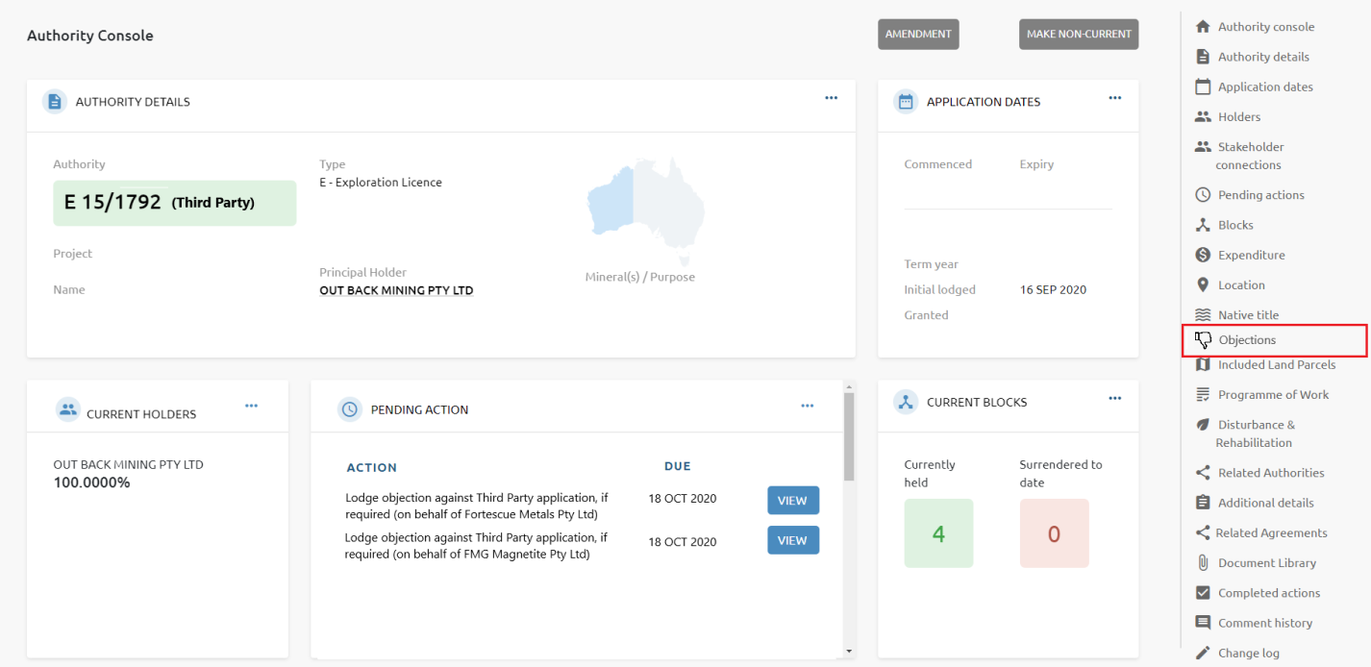

This new section will have 2 parts:

* Pre-Objection Assessments. Rows will be traffic light coloured according to all, some or no Decisions for the Third Party Authority.
  + All Assessments have a Decision – green
  + Some, but not all Assessments have a Decision – amber
  + No Assessments have a Decision - red
* Objections lodged (Objection numbers will be traffic light coloured according to their Priority).

The Objections section for a Managed Authority, will show all Pre-Objection Assessments and Objections Lodged (incoming and outgoing) directly related to the Managed Authority.

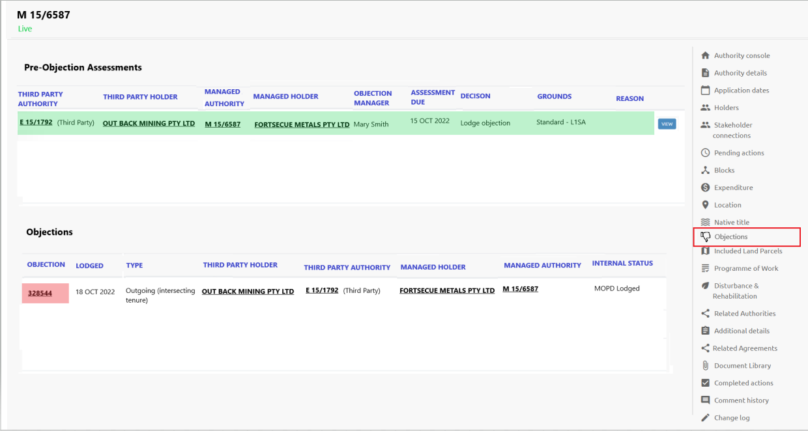

The Objections section for a Third-Party Authority, will show all FMG’s Pre-Objection Assessments and Objections Lodged (incoming and outgoing) directly related to the Third-Party Authority.

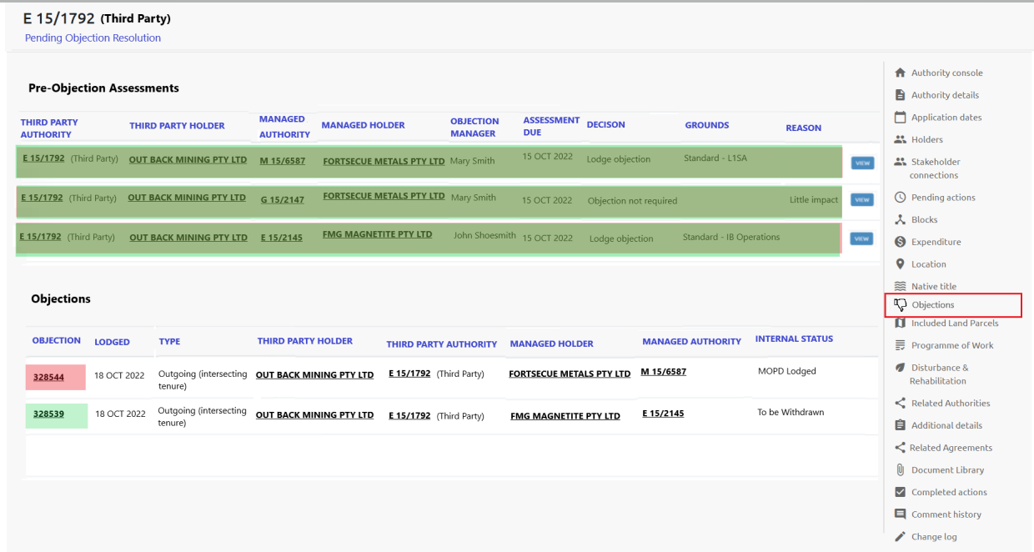

### Dealings

The side menu options for Authorities (both Managed and Third Party) will be expanded to include a new section for ‘Dealings’.

This section will display all Dealings recorded in eMITS, via the initial Import and the Department Audit.

The daily Department Audit will identify when existing Dealings have been amended or new Dealings have been created and will be reported. These new and updated Dealing records can be applied automatically (creating and replacing previous Dealings) and reported for acknowledgement.

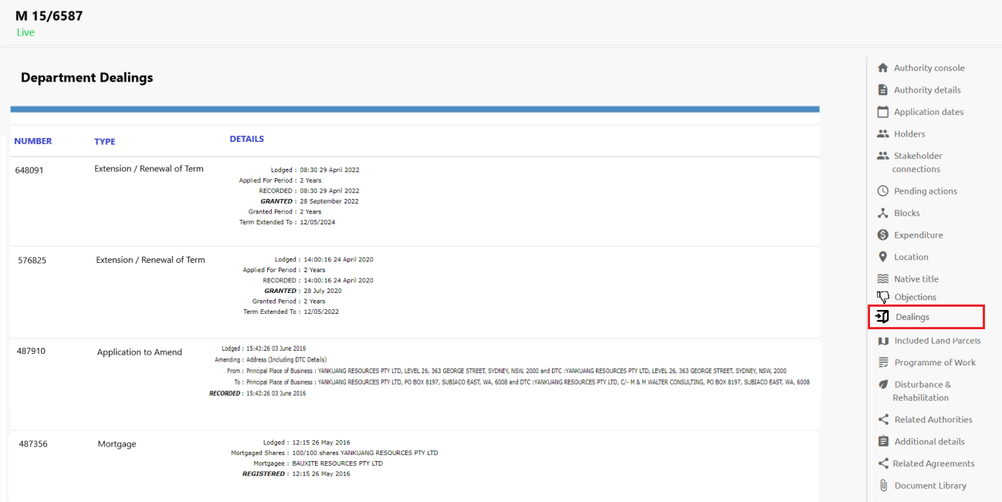

## Pre-objection Assessment

When Third-Party exploration and mining related applications are lodged with the Department that affect managed tenements, a written notification should be received (but not always) from the applicant (or authorised representative) which includes a copy of the Form 21 application and map of the area.

Assessment of application against each affected tenure is required by Objection Managers with a decision to formally lodge an objection or not by the objection closing date.

Via Change Request CR-016 (this requirement was previously misunderstood in the initial proposal), FMG require the Pre-Objection Assessment, decision, and applicable grounds for objection to be recorded.

When the Third-Party application is recorded in PX4, indicating an Assessment is required, a Pre-Objection Assessment record will automatically be created and link to the Third-Party Authority and each affected Managed Authority. This will also trigger a notification to the responsible Objection Manager.

The Objection Manager can click on their Notification or go directly to the Assessments list screen (via Objections on the Main Menu) to view all Assessment records.

### Assessment List

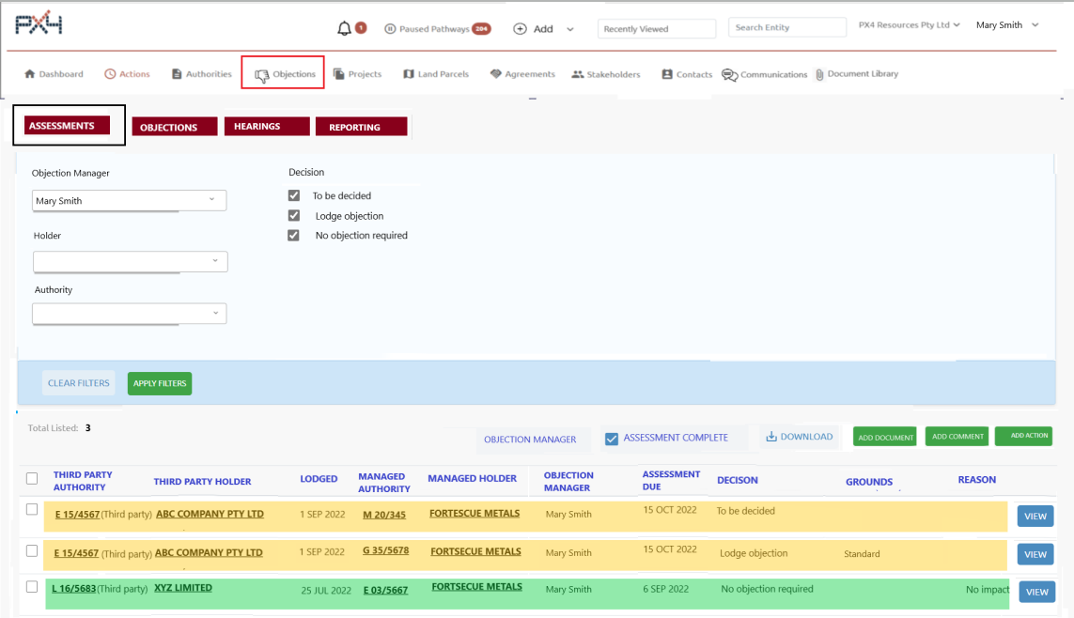

If the User is an Objection Manager, the list will default to Assessments with a decision status of ‘To be decided’, and will be assigned to that Objection Manager.

If the User is not an Objection Manager, the list will default to all Assessments for all Objection Managers with a decision status of ‘To be decided’.

Filters

* **Objection Manager** – drop down list of FMG managed Objection Managers. Leaving blank will display all, or one or more can be selected.
* **Holder** – drop down list of Stakeholders flagged as Authority Holder. Leaving blank will display all, or one or more can be selected. Managed and Third-Party Holders.
* **Authority** – drop down list of Authorities. Leaving blank will display all, or one or more can be selected. Managed and Third-Party Authorities.
* **Decision** – *To be decided*, *Lodge objection*, *No objection required*. One or more can be chosen.

List

* **Third Party Authority** – hyperlinked to Authority Console.
* **Third Party Holder** – hyperlinked to Stakeholder Console, comma delimited if multiple.
* **Lodged** – Third Party application lodged date.
* **Managed Authority** – hyperlinked to Authority Console.
* **Managed Holder** – hyperlinked to Stakeholder Console, comma delimited if multiple
* Objection Manager.
* **Assessment Due** – date assessment decision is due.
* **Decision** – To be decided, Lodge objection, No objection required.
* **Grounds** – Grounds for Objection if the decision is ‘Lodge objection’.
* **Reason** – Reason if the decision is ‘No objection required’.

Background colour for the row is dependent on whether all, some or *no* Assessments have been completed for the Third-Party Application.

* All Assessments have a Decision – green
* Some, but not all Assessments have a Decision – amber
* No Assessments have a Decision - red

Buttons

* **VIEW** – display the Assessment Detail screen.
* **OBJECTION MANAGER** – bulk update assigned Objection Manager for selected assessments. This will trigger a notification to the new Objection Manager if a different User logged in.
* **ASSESSMENT COMPLETE** – display Assessment Complete popup to bulk complete selected assessments.
* **DOWNLOAD** – download all Assessment data for selected assessments to an Excel spreadsheet.
* **ADD ACTION** button – ability to add an Action against the selected Third-Party applications. See Update existing, Create Action section.
* **ADD COMMENT** button – ability to add the same comment against the selected Third-Party applications.
* **ADD DOCUMENT** button – ability to add Documents against the selected Third-Party applications. See Update existing, Attach Document section.

### Assessment Detail

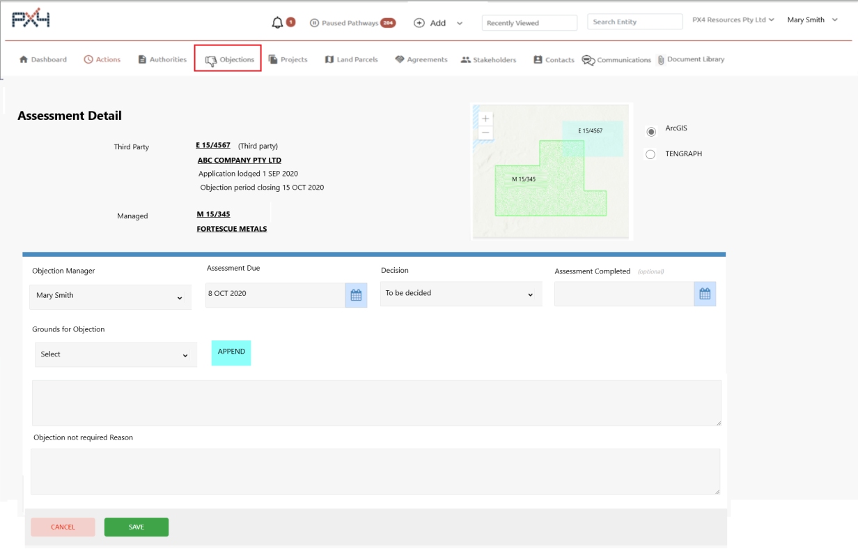

This screen is displayed when the VIEW button is clicked for an Assessment record.

It will display:

* **Third-Party** details (locked)
  + Third-Party Authority (hyperlinked to Authority Console)
  + Third-Party Holder/s (hyperlinked to Stakeholder Console)
  + Third-Party application lodged date
  + Third-Party application objection period closing date.
* **Managed** details (locked)
  + Managed Authority (hyperlinked to Authority Console)
  + Managed Holder/s (hyperlinked to Stakeholder Console).
* **GIS Map** showing the location of both the Third-Party Authority and the Managed Authority
  + Option to show using the customer’s spatial platform or the department’s spatial platform
  + Will need to research if the authority numbers can be displayed on the map.
* **Objection Manager** – drop down list of FMG managed Objection Managers. Mandatory.
* **Assessment Due** – date assessment decision is due. Mandatory.
* **Decision** – To be decided, Lodge objection, Objection not required. Mandatory.
* **Assessment Completed** – date assessment was completed. Required if Decision is Lodge objection or Objection not required.
* **Grounds for Objection** drop down – drop down list of FMG managed Grounds for Objection. Only displayed if the Decision is ‘Lodge objection’.
* **Grounds for Objection** text box – free format Grounds for Objection. Only displayed if the Decision is ‘Lodge objection’. Mandatory.
* **APPEND** button – append the selected Grounds for Objection drop down to the Grounds for Objection text box. Only displayed if the Decision is ‘Lodge objection’.
* **Objection not required Reason** – free format Reason. Only display if the Decision is ‘Objection not required’. Mandatory.

All updates will be recorded in the Change Log against the Third-Party Authority.

Changing Objection Manager is a trigger for a notification, if the chosen Objection Manager is different to the User logged in.

### Assessment Complete

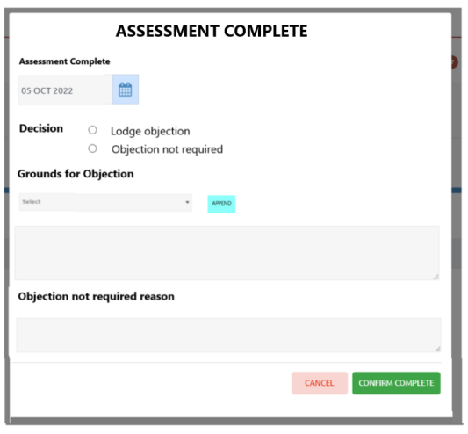

This popup is displayed when the ASSESSMENT COMPLETE button is clicked on the Assessment List screen for bulk completion of multiple assessments.

It will display:

* **Assessment Complete** – defaults to today’s date. Mandatory.
* **Decision** – Lodge objection or Objection not required. Mandatory.
* **Grounds for Objection** drop down – drop down list of FMG managed Grounds for Objection. Only displayed if the Decision is ‘Lodge objection’.
* **Grounds for Objection** text box – free format Grounds for Objection. Only displayed if the Decision is ‘Lodge objection’. Mandatory.
* **APPEND** button – append the selected Grounds for Objection drop down to the Grounds for Objection text box. Only displayed if the Decision is ‘Lodge objection’.
* **Objection not required Reason** – free format Reason. Only display if the Decision is ‘Objection not required’. Mandatory.

**CONFIRM COMPLETE** button

* Update the objection details for all selected Assessments
* Automatically complete the Pre-Objection Assessment action

All completed updates will be recorded in the Change Log against the Third-Party Authority for each assessment.

## Create Objection

Objections can be lodged by FMG against Third-Party applications affecting their managed authorities (Outgoing), or objections can be lodged by Third-Party Holders where their managed authorities are impacted by FMG mining or exploration related applications (Incoming).

Objections are lodged via WA eMITS Portal.

### Outgoing Objection

When a new Third-Party Authority was initially created indicating Assessment Required, a pathway workflow is triggered which will create an action ‘Lodge objection against third party application, if required’ for each unique Managed Holder.

For each of these actions, the Objection Administration Person will check the Pre-Objection Assessment list page for the final decision/s on the Third-Party Application for the Managed Holder.

If all Assessments are finalised and at least one pre-Objection Assessment decision by the Objection Manager for the Managed Holder is ‘Lodge objection’, an Objection will be lodged via WA eMITS Portal on behalf of the Managed Holder.

When the Objection Administration Person, completes the ‘Lodge objection’ action, the pathway will ask the question ‘If an objection has been lodged?’. If ‘No’, the pathway updates the status for the Third-Party Authority and the process finishes. If ‘Yes’, the pathway updates the status for the Third-Party Authority and a blank Create Objection screen will be displayed to record the Objection details lodged.

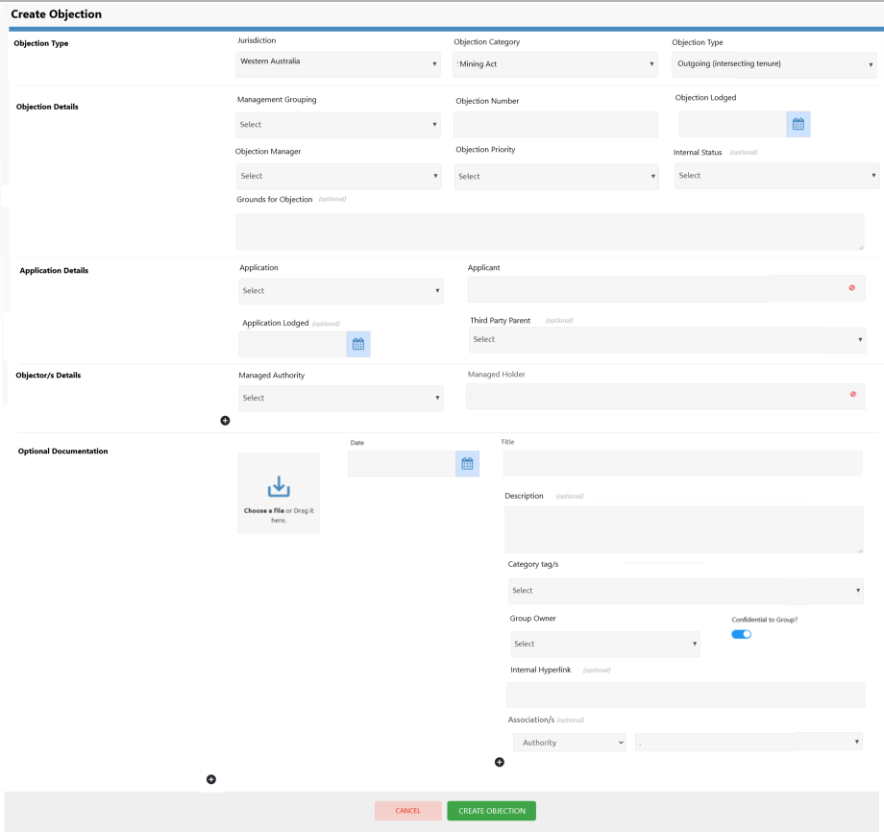

**Jurisdiction** – defaults to Western Australia.

**Objection Category** – defaults to Mining Act.

**Objection Type** – choose **Outgoing (intersecting tenure)**.

**Management Grouping** – the stakeholder responsible for managing the Objection actions. For PX4 customers managing objections for multiple clients, Management Grouping would be their client.

**Objection Number** – WA eMITS objection number.

**Objection Lodged** – date the objection was lodged on WA eMITS portal.

**Objection Manager** - drop down list of FMG managed Objection Managers (see Managed Lists).

**Objection Priority** – drop down list of FMG managed Objection Priority (see Managed Lists). Determines traffic light colour.

**Internal Status** – drop down list of FMG managed Internal Status (see Managed Lists). Optional.

**Grounds for Objection** – copy and paste what was lodged on WA eMITS portal and appears on Form 16. Optional.

**Application** – drop down list of Third-Party Authorities. (Management Type of Third Party).

**Applicant** – Current Holder/s for the chosen Third-Party Authority. Display only.

**Application Lodged** – date the Third-Party application was lodged.

**Third Party Parent** – drop down list of Stakeholders. Optional.

**Managed Authority** – drop down list of Managed Authorities. (Management Type of Managed).

**Managed Holder** – Current Holder/s for the chosen Managed Authority. Display only.

**Optional Document/s** – Attach one or more documents, which will be automatically associated with the Third-Party Authority and Managed Authority/s.

**CREATE OBJECTION button:**

* New Objection record is created
* Initiates pathway workflow for an Outgoing (intersecting tenure) Objection to update status and create Actions.

### Incoming Objection

Objections lodged in WA eMITS portal against an FMG application in PX4, will be picked up overnight and identified by the Department Audit function. The basic Objection record will be automatically created as Incoming (intersecting tenure), linked to the Managed Authority (application) and a pathway workflow initiated.

The only Objection data available will be Objection Number, Department Status of RECORDED, Objection Lodged date and the Objector Stakeholder.

The pathway will automatically create actions to ‘Review the new objection received and check internal ownership’ and ‘Receipt of Letter of Service and stamped Form 16 from Objector’.

If required, the Incoming Objection can be manually created, by clicking Add > Objection on the top Header line.

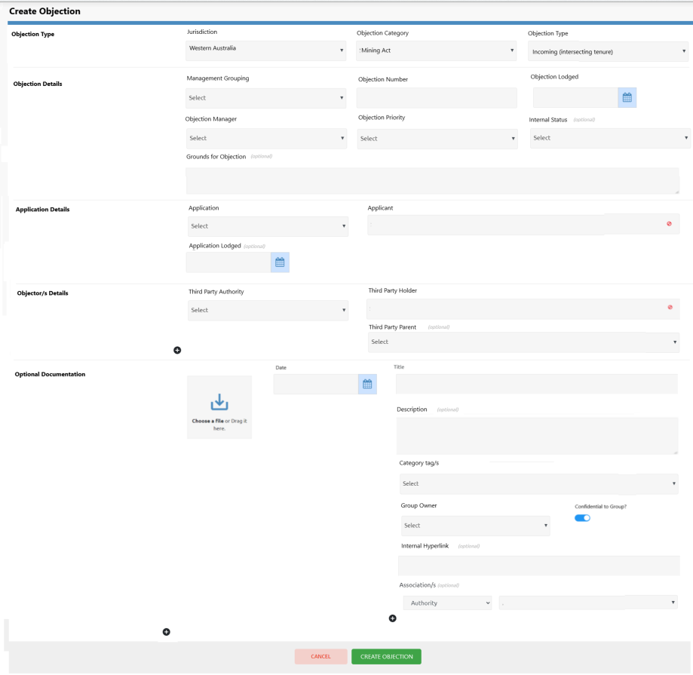

**Jurisdiction** – defaults to Western Australia.

**Objection Category** – defaults to Mining Act.

**Objection Type** – choose **Incoming (intersecting tenure).**

**Management Grouping** – the stakeholder responsible for managing the Objection actions. For PX4 customers managing objections for multiple clients, Management Grouping would be their client.

**Objection Number** – objection number given by the department.

**Objection Lodged** – date the objection was lodged with the department.

**Objection Manager** – drop down list of FMG managed Objection Managers (see Managed Lists).

**Objection Priority** – drop down list of FMG managed Objection Priority (see Managed Lists). Determines traffic light colour.

**Internal Status** – drop down list of FMG managed Internal Status (see Managed Lists). Optional.

**Grounds for Objection** – copy and paste what was lodged on WA eMITS portal and appears on Form 16. Optional.

**Application** – drop down list of Managed Authorities. (Management Type of Managed).

**Applicant** – Current Holder/s for the chosen Managed Authority. Display only.

**Application Lodged** – date the application was lodged.

**Third Party Authority** – drop down list of Third-Party Authorities (Management Type of Third Party).

**Third Party Holder** – Current Holder/s for the chosen Third-Party Authority. Display only.

**Third Party Parent** – drop down list of Stakeholders. Optional.

**Optional Document/s** – Attach one or more documents, which will be automatically associated with the Third-Party Authority and Managed Authority/s.

**CREATE OBJECTION button:**

* New Objection record is created
* Initiates pathway workflow for an Incoming (intersecting tenure) Objection to update status and create Actions.

## Objections and Hearings List



Via Change Request CR-014, FMG have requested flexible objection list screens where each User can choose their own filters and columns to be displayed and also have the ability to save / update their own default preference.

This is a different format to our existing list screens in PX4. Rather than creating this functionality from scratch, our development team have found an existing code library that can be used for this purpose and still allow bulk functionality and entity hyperlinks, but it will need to be amended to make it work within our existing product.

This is what we propose to use as a starting point

[JavaScript Data Grid: AG Grid: High-Performance React Grid, Angular Grid, JavaScript Grid (ag-grid.com)](https://ag-grid.com/)

### Objection API

An API will need to be created to allow the various Objection related columns to be selected and filtered:

* Jurisdiction
* Objection Category
* Objection Type
* Objection Number
* Phase (active, finalised)
* Status
* Management Grouping
* Objection Lodged
* Objection Finalised
* Applicant
* Application
* Application Lodged Date
* Third Party Parent
* Objector (comma delimited if multiple)
* Objector Authority (comma delimited if multiple)
* Project (from Managed Authority)
* Mineral Field (from Managed Authority)
* Objection Manager
* Age (days)
* External Legal Representative
* External Legal Representative Reference
* Internal Legal Representative
* Objection Priority
* Internal Status
* Negotiation Status
* Resolution Status
* Grounds for Objection
* Area Review
* Registered Post Number
* Department Status
* Department Status Date
* Department Dealing
* Objection Comments
* Next Hearing Sequence
* Next Hearing Type
* Next Hearing Date
* Next Hearing Time
* Next Hearing Location
* Next Hearing Instruction
* Next Hearing Instruction Complete?
* Next Action
* Next Action Due Date
* Next Action Assigned To.

### Objections List

To view the Objections list screen, click Objections on the Main Menu and then the Objections tab.

Advanced User Permissions will apply if the User can have editor access, viewer access or restricted access to any of the Objections listed.

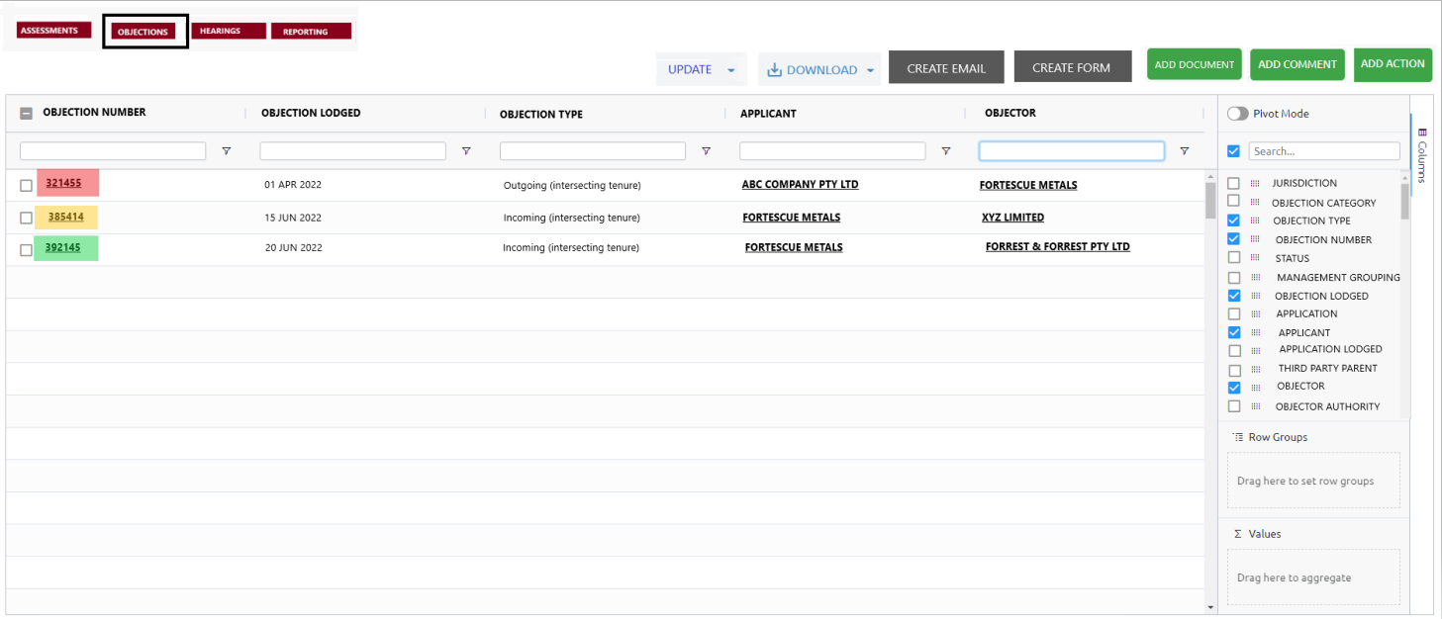

This new list format will allow the User to:

* Choose the columns they want to see
* Move those columns around
* Sort columns
* Filter data within the columns
* Set and re-set preference
* much, much more!

**ADD ACTION** button – ability to add an Action against the selected Objections. See Update existing, Create Action section.

**ADD COMMENT** button – ability to add the same comment against the selected Objections.

**ADD DOCUMENT** button – ability to add Documents against the selected Objections. See Update existing, Attach Document section.

**CREATE FORM** button – ability to create a word or PDF merged form using a selected form template for the selected Objections. See Create Forms section.

**CREATE EMAIL** button – ability to create a merged email using a selected email template for the selected Objections. See Create Emails.

**DOWNLOAD** button – ability to either download the columns currently displayed for selected Objections, download all data for selected Objections.

**UPDATE** button – ability to bulk update certain fields for the selected Objections. The fields that can be updated are:

* Management Grouping
* Third Party Parent
* Objection Manager
* External Legal Representative
* Internal Legal Representative
* Objection Priority
* Internal Status
* Negotiation Status
* Resolution Status
* Area Review.

#### Create Forms

When Objections require a standard form to be created pre-filled with objection data, select the applicable Objections on the Objection List screen and click the CREATE FORM button.

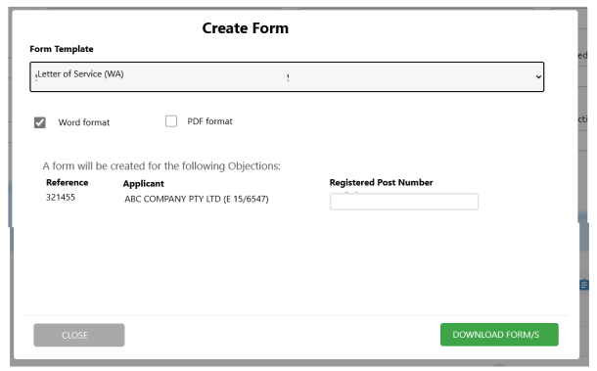

The available Form Templates will be FMG managed in the Administration Portal.

Choose the Form Template you wish to use.

Indicate if you want the form to be in Word format or PDF format.

The selected Objections to be merged with the form will be displayed.

If the selected Form requires a Registered Post Number (eg Letter of Service), enter the Registered Post Number against each Objection. Each number will be saved against the Objection.

Click DOWNLOAD FORM/S button.

Each merged form will be downloaded for easy amending (if in Word format), printing, attaching to emails, saving in document library.

Each time a form is generated, a log will be generated in the Master Activity Log.

#### Create Emails

Via Change Request CR-010, when Objections require a standard email to be created pre-filled with objection data, select the applicable Objections on the Objection List screen or Hearing List screen and click the CREATE EMAIL button.

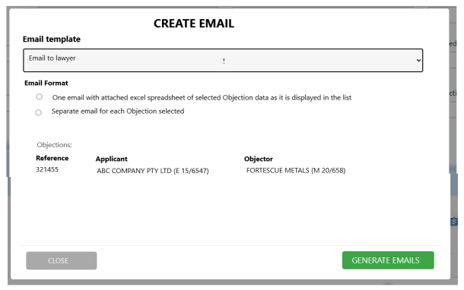

The available Email Templates will be FMG managed in the Administration Portal.

Choose the Email Template you wish to use.

Indicate the required email format:

* One email with an attached Excel spreadsheet of the selected Objection data as it is displayed in the list
* Separate email for each Objection selected in the list.

The selected Objection data to be merged with the email will be displayed.

Click GENERATE EMAIL/S button.

The email/s will be displayed to the User for possible amending.

Once the email is generated is displayed it has left control of the PX4 server and is now in control of the User’s email provider. PX4 does not know if it has been sent or not.

Each time an email is generated, a log will be generated in the Master Activity Log. Even if the email is not ultimately sent, the log will indicate the email was generated.

### Hearings API

An API will need to be created to allow the various Objection related columns to be selected and filtered:

* Objection Number
* Applicant
* Application
* Objector (comma delimited if multiple)
* Objector Authority (comma delimited if multiple)
* Objection Manager
* Hearing Sequence
* Hearing Type
* Hearing Date
* Hearing Time
* Hearing Location
* Hearing Attendee
* Hearing Status
* Hearing Instructions
* Hearing Instructions Complete
* External Legal Representative
* External Legal Representative Reference
* Internal Legal Representative
* Comments.

### Hearings List

To view the hearings list screen, click Objections on the Main Menu and then the Hearings tab.

Advanced User Permissions will apply if the User can have editor access, viewer access or restricted access to any of the Objections listed.

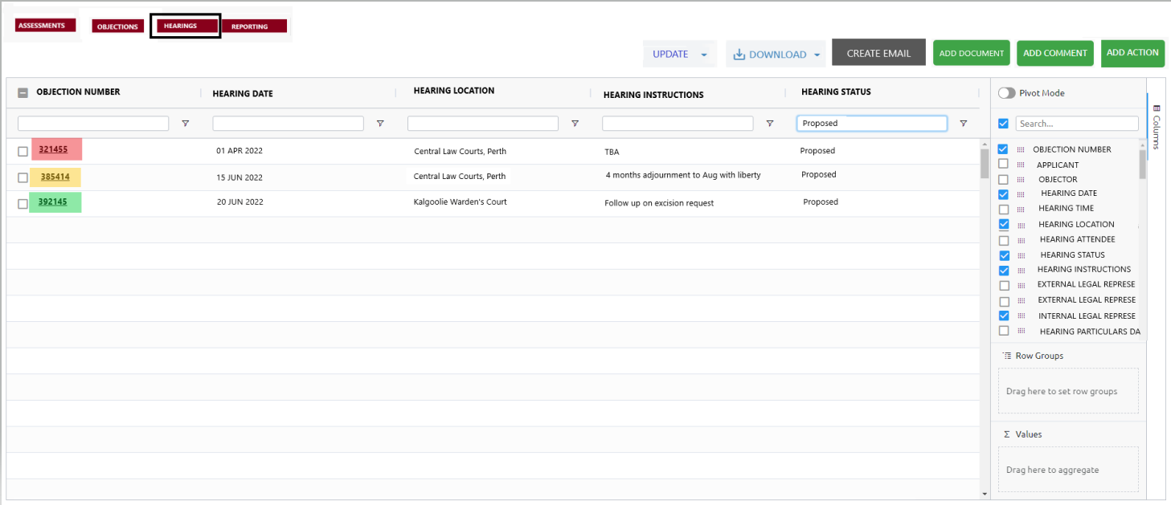

This new list format will allow the User to:

* Choose the columns they want to see
* Move those columns around
* Sort columns
* Filter data within the columns
* Set and re-set preference
* much, much more!

**ADD ACTION** button – ability to add an Action against the selected Objections. See Update existing, Create Action section.

**ADD COMMENT** button – ability to add the same comment against the selected Hearings.

**ADD DOCUMENT** button – ability to add Documents against the selected Objections. See Update existing, Attach Document section.

**CREATE EMAIL** button – ability to create a merged email using a selected email template for the selected Hearings. See Create Emails.

**DOWNLOAD** button – ability to either download the columns currently displayed for selected Hearings, download all data for selected Hearings.

**UPDATE** button – ability to bulk update certain fields for the selected Hearings. The fields that can be updated are:

* Hearing Location
* Hearing Attendee
* Hearing Instructions.

## Objection Console and Side Menu Options

Whenever a hyperlinked Objection Number (bold and underlined) is clicked within PX4, the Objection Console will be displayed.

Advanced User Permissions will apply if the User can have access, editor access, viewer access or restricted access to this Objection.

**Side Menu** options:

* **Objection Console** – navigates back to the Objection Console if you are in another section for this Objection
* **Objection Details** – link to Objection Details screen
* **Objectors** – link to the Objectors screen
* **Hearing History** – link to the Hearing History screen
* **Pending Actions** – link to the Pending Actions screen
* **Related Agreements** – link to the Related Agreements screen
* **Document Library** – link to the Document Library screen
* **Completed Actions** – link to the Completed Actions screen
* **Comment History** – link to the Comment History screen
* **Change Log** – link to the Change Log screen.

### Objection Console

The Objection Console displays a summary of current objection relevant data on ‘cards’. The information is pulled directly from the database.

Depending on the Objection Type, some of the data and labels will display differently. This is managed by the PX4 Studio.

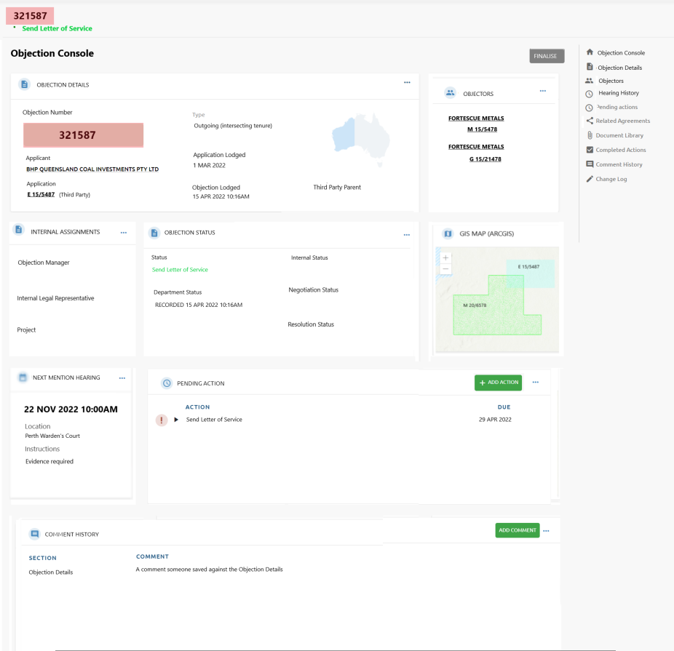

**OBJECTION DETAILS** card:

* **Objection Number** – traffic light coloured based on the Objection Priority (FMG managed).
* **Applicant**
  + if an Outgoing Objection, this will be the Third-Party Holder. Hyperlinked to the Stakeholder Console
  + If an Incoming Objection, this will be the Managed Holder. Hyperlinked to the Stakeholder Console.
* **Application**
  + If an Outgoing Objection, this will be Third Party application number. Hyperlinked to the Authority Console.
  + If an Incoming Objection, this will be the Managed application number. Hyperlinked to the Authority Console.
* **Type** – type of objection – Outgoing (intersecting tenure) or Incoming (intersecting tenure).
* **Application Lodged** – date the application was lodged.
* **Objection Lodged** – date the objection was lodged.
* **Third Party Parent**
  + if an Outgoing Objection the Applicant’s parent company, if applicable. Hyperlinked to the Stakeholder Console.
  + If an Incoming Objection, not displayed on this card. It will be displayed with the Objectors.
* **Jurisdiction** – graphic highlighting the jurisdiction.
* **3 dots** – link to the Objection Detail screen.

**OBJECTORS** card

For all objectors linked:

* **Managed Holder** – this is an Outgoing Objection, so the Managed Stakeholder. Hyperlinked to the Stakeholder Console.
* **Managed Authority** – this is an Outgoing Objection, so the Managed Authority. Hyperlinked to the Authority Console.
* **3 dots** – link to the Objectors screen.

**INTERNAL ASSIGNMENTS** card

* **Objection Manager** – assigned Manager for the Objection. List of Objection Managers managed within Administration Portal
* **Internal Legal Rep** - assigned Internal Legal Representative for the Objection. List of Internal Legal Representatives managed within Administration Portal
* **Project** – project/s linked to the Managed Authority/s. Hyperlinked to the Project Console.
* **3 dots** – link to the Objection Detail screen

**OBJECTION STATUS** card

* **Status** – PX4 pathway managed status. Locked
* **Department Status** – Department managed status, updated via Tenement Gateway. Locked
* **Internal Status** – manually assigned. List of valid Internal Status managed within Administration Portal
* **Negotiation Status** - manually assigned. List of valid Negotiation Status managed within Administration Portal
* **Resolution Status** - manually assigned. List of valid Resolution Status managed within Administration Portal
* **3 dots** – link to the Objection Detail screen

**GIS MAP** card

If connection credentials are saved in the Administration Portal to an internal spatial mapping platform (eg ArcGIS), this card will display the parcel for the Application and objecting Managed Authority/s. If no connection credentials are saved, this card will use TENGRAPH to display the parcels for the Application and objecting Managed Authority/s.

Research is required to see if the tenure numbers can display, and different colours are possible.

**NEXT MENTION HEARING** card:

* **Date and Time** – date and time of the latest Hearing record in sequence. Note, may not be Proposed.
* **Location** – physical location of the latest Hearing record in sequence. List of valid Hearing Locations are managed within the Administration Portal.
* **Instructions** – instructions saved against the latest Hearing record in sequence.
* **3 dots** – link to the Hearing Detail screen for the latest Hearing record in sequence.

**PENDING ACTIONS** card

For all Actions not yet completed for this Objection:

* **ACTION** – Action name
* **DUE** – due date
* **VIEW** button– link to Action Detail screen
* **ADD ACTION** button – link to blank Create Action screen to create one action against this Objection.
* **3 dots** – link to the Pending Actions screen.

**COMMENT HISTORY** card

For all comments saved against all sections for this Objection:

* **SECTION** – side menu section for the comment
* **COMMENT** – comment saved
* **ADD COMMENT** button – popup to create a comment against the Objection Details section for this Objection.
* **3 dots** – link to Comment History screen.

**FINALISE** button:

* will initiate the Objection Finalise pathway to close off the Objection
* can be initiated at any time.

### Objection Detail

Depending on the Objection Type, some of the data and labels will display differently. This is managed by the PX4 Studio.

All updates to this screen will be recorded in the Change Log for the Objection – who, when and what.

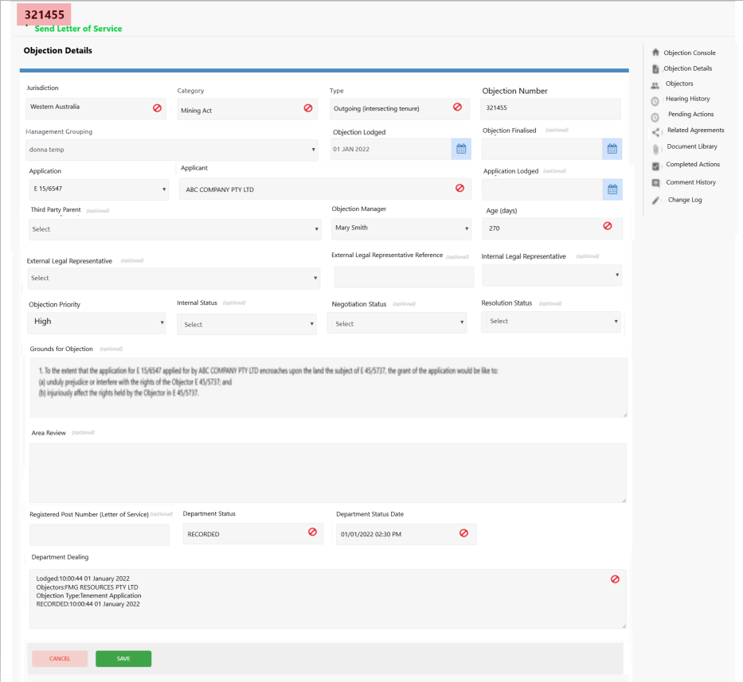

**Jurisdiction** – locked.

**Objection Category** – locked.

**Objection Type** – locked, because the pathway workflow initiated depends on the Objection Type.

**Objection Number** – number given by the department.

**Management Grouping** – the stakeholder responsible for managing the Objection actions. For PX4 customers managing objections for multiple clients, Management Grouping would be their client.

**Objection Lodged** – date the objection was lodged with the department.

**Objection Finalised** – date the objection was finalised.

**Application:**

* If an Outgoing Objection, this will be Third Party application number.
* If an Incoming Objection, this will be the Managed application number.

**Applicant:**

* if an Outgoing Objection, this will be the Third-Party Holder.
* If an Incoming Objection, this will be the Managed Holder.

**Application Lodged** – date the application was lodged.

**Third Party Parent:**

* if an Outgoing Objection the Applicant’s parent company, if applicable.
* If an Incoming Objection, not displayed on this screen. It will be displayed with the Objectors.

**Objection Manager** – assigned Manager for the Objection. Dropdown list managed within Administration Portal.

**Age (Days)** – locked, calculated field. Today’s date less Objection Lodged date.

**External Legal Representative** – stakeholder flagged with role of Legal Representative.

**External Legal Representative Reference** – the external legal representative’s reference number for this Objection.

**Internal Legal Representative** – assigned Internal Legal Representative for the Objection. Dropdown list managed within Administration Portal.

**Objection Priority** – assigned priority to the business for this Objection. The value determines the traffic light colour for the objection number. Dropdown list managed within Administration Portal.

**Internal Status** – assigned internal status for this Objection. Dropdown list managed within Administration Portal.

**Negotiation Status** – assigned negotiation status for this Objection. Dropdown list managed within Administration Portal.

**Resolution Status** – assigned resolution status for this Objection. Dropdown list managed within Administration Portal.

**Grounds for Objection** – grounds for objection for this Objection lodged with the department.

**Area Review** – ground assessment notes.

**Registered Post Number (Letter of Service)**

* If an Outgoing Objection, the registered post number for the Letter of Service. Required for creating the Letter of Service from a template.
* If an Incoming Objection, not applicable and is not displayed.

**Department Status** – locked, updated via Tenement Gateway.

**Department Status Date** – locked, updated via Tenement Gateway.

**Department Dealing** – locked, updated via Tenement Gateway.

**Comment History:**

* Comments saved against this section, including who and when.
* Comments can only be edited or deleted by the Administrator.

**Triggers for Notification**

To Objection Manager:

* Updates made to data by a User NOT the assigned Objection Manager
* Comment made by a User NOT the assigned Objection Manager.

Other

* @ tagged a PX4 registered User within comments to the tagged User
* Replied to another User’s comment to the other User.

### Objectors

Depending on the Objection Type, some of the data and labels will display differently. This is managed by the PX4 Studio.

All updates to this screen will be recorded in the Change Log for the Objection – who, when and what.

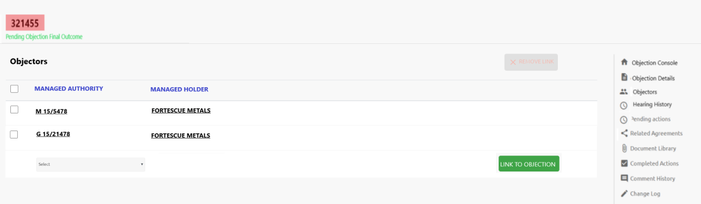

List of all Objectors for this Objection.

If Outgoing Objection type:

* Managed Authority column heading – hyperlinked to Authority Console
* Managed Holder column heading – hyperlinked to Stakeholder Console
* Authority dropdown using Select – list of Authorities with Management Type of Managed.

If Incoming Objection type:

* Third Party Authority column heading – hyperlinked to Authority Console
* Third Party Holder column heading – hyperlinked to Stakeholder Console
* Authority dropdown using Select – list of Authorities with Management Type of Third Party.

**LINK TO OBJECTION** button – link the chosen Authority in the dropdown to this Objection as an Objector.

**REMOVE LINK** button – remove the link for the selected Objector/s from this Objection.

**Triggers for Notification**

To Objection Manager:

* Updates made to data by a User who is NOT the assigned Objection Manager.

### Hearing History

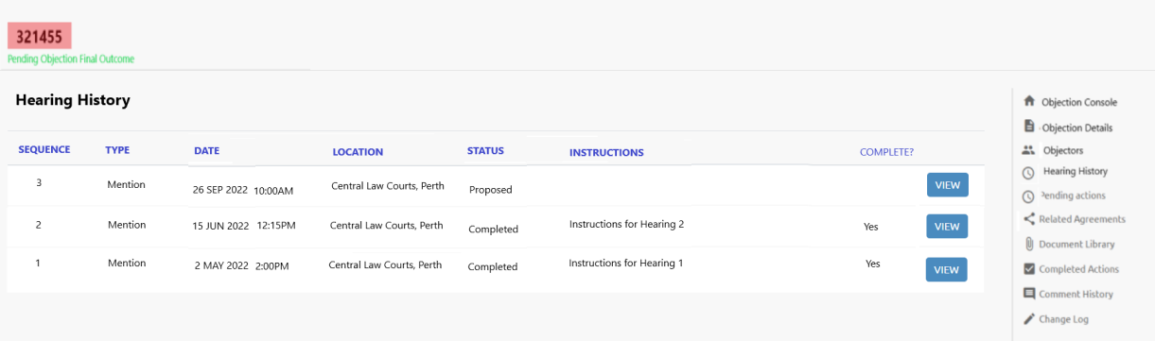

List of all Hearings for this Objection, with the latest at the top.

**Sequence** – Hearing number, sequential order.

**Type** – Hearing Type – Mention or Trial

**Date** – scheduled date and time for the Hearing.

**Location** – location of the Hearing.

**Status** – status of the Hearing. Proposed, Completed.

**Instructions** – any instructions given by the Objection Manager for the Hearing.

**Complete?** – are the Instructions flagged as complete or not

**VIEW** button – links to the Hearing Detail screen.

### Hearing Detail

All updates to this screen will be recorded in the Change Log for the Objection – who, when and what.

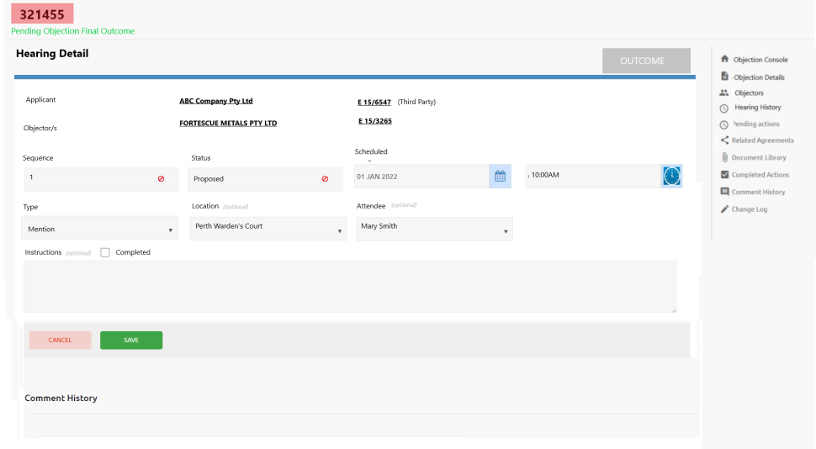

**Applicant** – locked, display only:

* Third Party Holder or Managed Holder, depending on the type of objection. Hyperlinked to Stakeholder Console.
* Third Party Authority or Managed Authority, depending on the type of objection. Hyperlinked to Authority Console.

**Objector/s** – locked, display only list of:

* Third Party Holder or Managed Holder, depending on the type of objection. Hyperlinked to Stakeholder Console.
* Third Party Authority or Managed Authority, depending on the type of objection. Hyperlinked to Authority Console.

**Sequence** – locked, automatically generated by the pathway when the next Hearing is created.

**Status** – locked, automatically updated by the pathway. Proposed, Completed.

**Scheduled** – date and time for the Hearing.

**Type** – type of Hearing. Mention or Trial.

**Location** – location of the Hearing. Dropdown list managed within Administration Portal.

**Attendee** – optional internal User assigned to attend the Hearing.

**Instructions** – instruction notes given by the Objection Manager for the Hearing.

Instructions **Completed** – checkbox to indicate the Instructions are now complete

**OUTCOME** button – only display if the Hearing Status is Proposed. When clicked displays the new Hearing Outcome popup.

**Comment History:**

* Comments saved against this hearing, including who and when
* Comments can only be edited or deleted by the Administrator.

**Triggers for Notification**

To Objection Manager:

* Updates made to data by a User NOT the assigned Objection Manager
* Comment made by a User NOT the assigned Objection Manager.

Other:

* @ tagged a PX4 registered User within comments to the tagged User
* Replied to another User’s comment to the other User.

#### Hearing Outcome

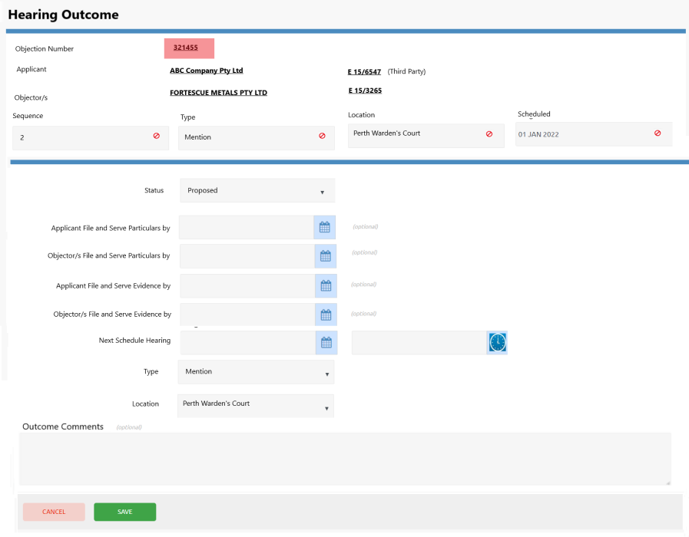

**Objection Number** – Objection number hyperlinked to Objection Console (new tab). Background traffic light colour dependent on Priority.

**Applicant** – Applicant Stakeholder hyperlinked to Stakeholder Console (new tab), applicant authority hyperlinked to Authority Console (new tab)

**Objector/s** – Objector Stakeholder hyperlinked to Stakeholder Console (new tab), objector authority hyperlinked to Authority Console (new tab)

**Sequence** – hearing sequence. locked

**Type** – type of hearing. locked

**Location** – hearing location. locked

**Scheduled** – scheduled hearing date. locked

**Status** – Default to Proposed, but can be changed to Completed

**Applicant File and Serve Particulars By** – applicant particulars due date, optional. If date entered an action will be automatically generated via the pathway in Process Map

**Objector/s File and Serve Particulars By** – objector particulars due, optional. If date entered an action will be automatically generated via the pathway in Process Map

**Applicant File and Serve Evidence By** – applicant evidence due date, optional. If date entered an action will be automatically generated via the pathway in Process Map

**Objector/s File and Serve Evidence By** – objector evidence due date, optional. If date entered an action will be automatically generated via the pathway in Process Map

**Next Scheduled Hearing** – date and optional time

**Type** – default to existing Hearing Type but can be changed

**Location** – default to existing Hearing Location but can be changed

**Outcome Comments** – free-format

**SAVE** button

* Automatically complete the Hearing Outcome Action associated with this Hearing
* If Applicant File and Serve Particulars has a date entered
  + Initiate the Applicant Particulars pathway to create the Action with a due date of the entered date
* If Objector File and Serve Particulars has a date entered
  + Initiate the Objector Particulars pathway to create the Action with a due date of the entered date
* If Applicant File and Serve Evidence has a date entered
  + Initiate the Applicant Evidence pathway to create the Action with a due date of the entered date
* If Objector File and Serve Evidence has a date entered
  + Initiate the Objector Evidence pathway to create the Action with a due date of the entered date
* If Next Scheduled Hearing has a date entered
  + Initiate the Next Hearing pathway to create the next proposed hearing
* Save Outcome Comments against the Hearing Detail record

### Pending Actions

All updates to this screen will be recorded in the Change Log for the Objection – who, when and what.

List of all pending Actions for this Objection:

**‘Play’** icon – if the action displays a play icon, this means the action is on a pathway and the action must be completed for the next step in the process to be activated.

**Type** – type of action.

**Action** – action name.

**‘Time Related’** icon – a different icon is displayed if the action is overdue, due in 2 weeks or due in 2-4 weeks.

**Due** – due date for the action.

**‘Comment’** icon – If a comment has been saved against the Action, hover over this icon to display the last comment.

**VIEW** button – link to the Action Detail screen.

**ADD ACTION** button – link to the Create Action screen to create a new Action.

**DELETE** button – bulk delete of selected Actions:

* Actions with a ‘Play’ icon cannot be deleted as they are on a pathway
* Statutory Locked Actions can only be deleted by the Administrator, as non-compliance is risked.

**DATES** button – bulk update of notification and due dates of selected Actions.

* Statutory Locked Actions can only have their due dates updated by the Administrator, as non-compliance is risked.

**REASSIGN** button – bulk reassign the selected Actions to a different User.

**COMPLETE** button – bulk complete the selected Actions with the same completion date and optional comment.

**Triggers for Notification**

To Objection Manager

* Updates made to Action data by a User NOT the assigned Objection Manager.

To Assigned User

* Updates made to Action data by a User NOT the Assigned To User.

Collaborator

* Updates made to Action data by a User NOT the Collaborator.

### Related Agreements

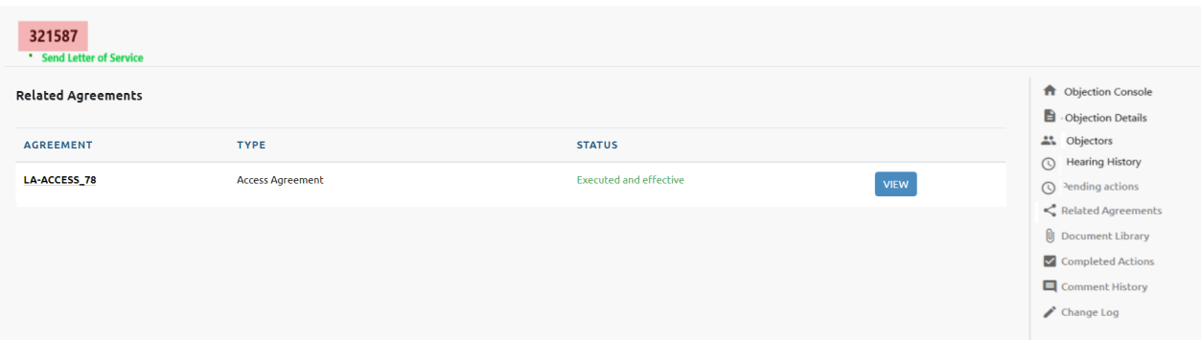

List of Agreements linked to this Objection.

**Agreement** – agreement reference number, either supplied and PX4 generated.

**Type** – type of agreement.

**Status** – current status of the agreement.

**VIEW** button – linked to the Agreement Console.

### Document Library

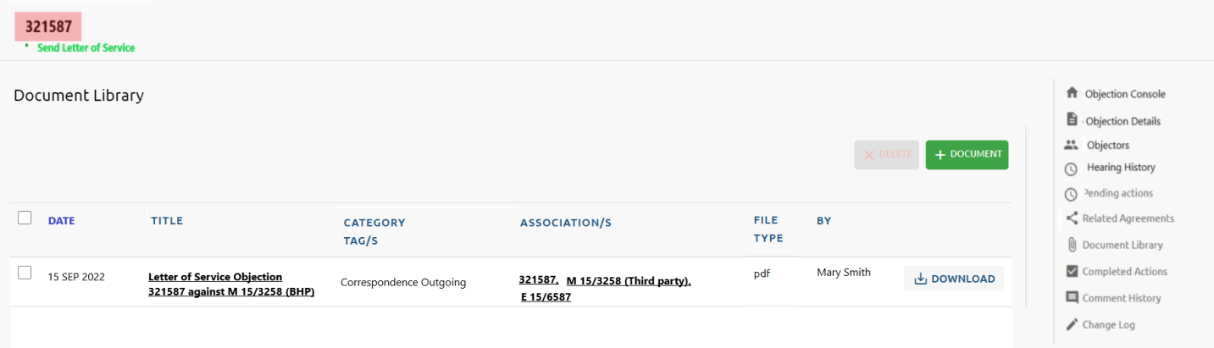

List of documents with an association with this Objection.

**Date** – document’s relevant date.

**Title** – meaningful short description of the document. Hyperlinked to the Document Details screen.

**Category Tag/s** – type of document. Can be more than one. Available tags are currently maintained by PX4 Software.

**Association/s** – all Entities this document relates to. All Entities are hyperlinked to their Console.

**File Type** – file extension for the document.

**By** – who uploaded the document.

**DOWNLOAD** button – downloads a copy of the document.

### Completed Actions

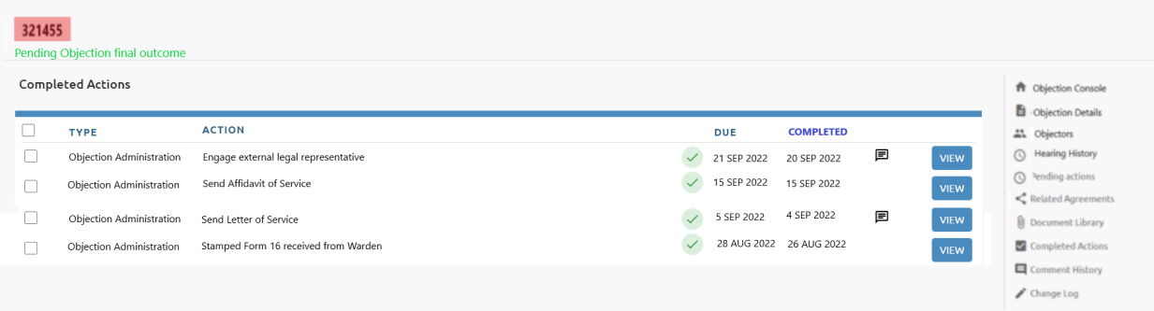

List of all completed Actions for this Objection.

**Type** – type of action.

**Action** – action name.

**‘Time Related’** icon – a completed icon is displayed.

**Due** – due date for the action.

**Completed** – date the action was completed.

**‘Comment’** icon – If a comment has been saved against the Action, hover over this icon to display the last comment.

**VIEW** button – link to the Action Detail screen.

### Comment History

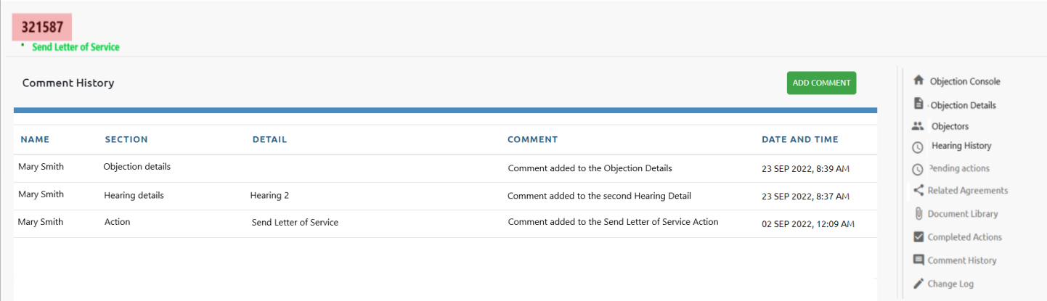

List of all comments saved against all sections for this Objection.

**Name** – who made the comment.

**Section** – which section was the comment added.

**Detail** – if multiple records for a section, which record was the comment added.

**Comment** – the actual comment.

**Date and Time** – when was the comment added.

**ADD COMMENT** button – add a new comment against the Objection Detail section.

### Change Log

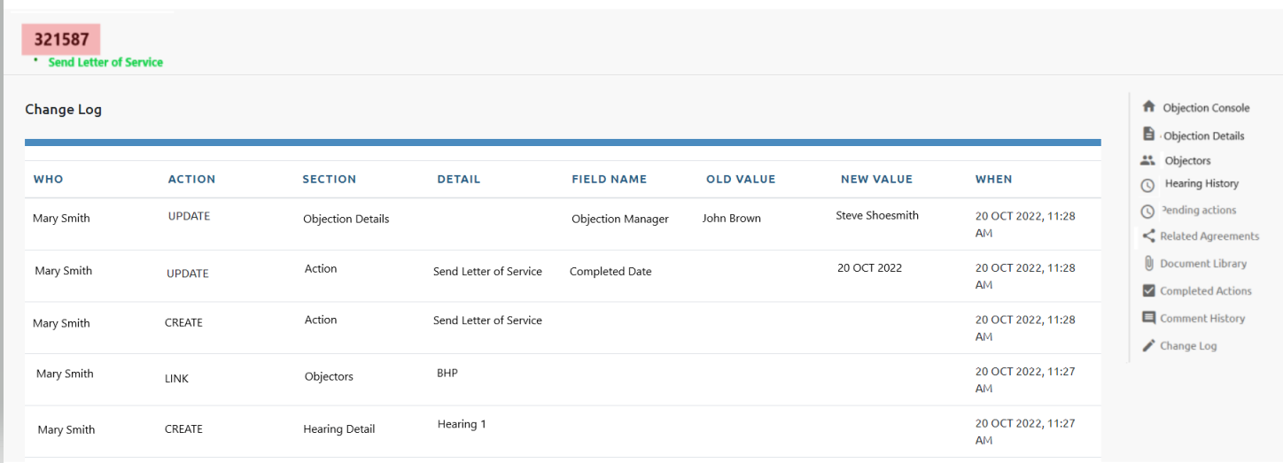

List all changes (create, update, delete) to this Objection, including responses to pathway steps.

**Who** – who made the change.

**Action** – type of change – create, update, delete, link, remove link, input step, update step, question step.

**Section** – which section was the change made, or pathway.

**Detail** – if multiple records for a section, which record was the change made, or step name if it was a pathway change.

**Field Name** – which field was changed.

**Old Value** – if a field was updated, what was the before value.

**New Value** – if a field was updated, what was the after value.

**When** – when was this change made.

## Actions



Advanced User Permissions will apply if the User can have access, editor access, viewer access or restricted access to any of the Actions for each Entity.

#### Pathway created Actions

Statutory Locked Actions have the due date set as the statutory due date with the Group’s Escalation Process triggered if they are not completed leading up to the due date.

Actions automatically generated by the pathways in the Process Maps section, will be the following:

**Pre-Outgoing Objection Assessment:**

Linked to the Third-Party Authority



**Outgoing Objection**

Linked to the Objection

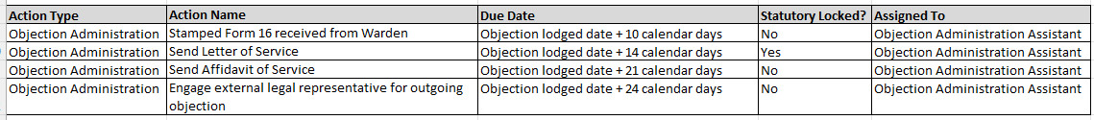

**Incoming Objection**

Linked to the Objection

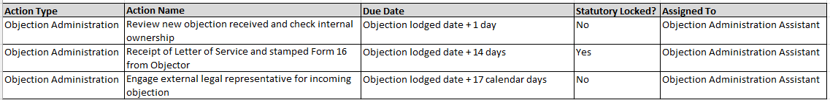

**Objection Hearing**

Linked to the Objection

#### Update existing Action List

Update to allow the ability to filter for Action Assigned / Collaborator as well as the primary Assigned User.

Display Actions linked to Objection entities with the traffic light colour according to the Objection Priority.

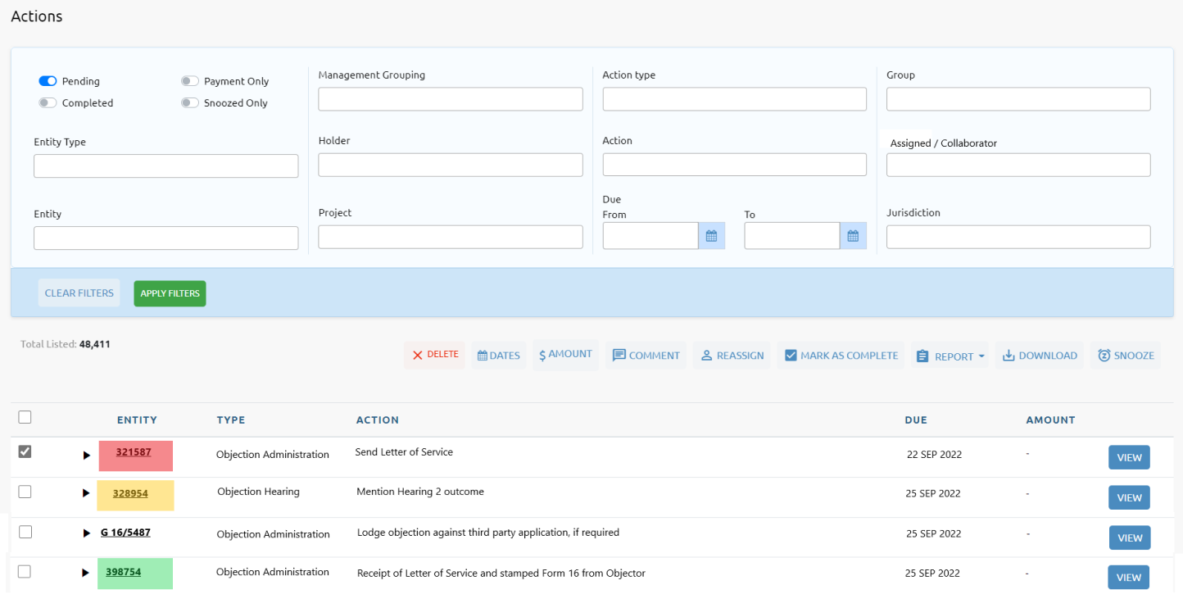

Via Change Request CR-009, the REPORT button will be expanded for an additional report ‘Obligations Forecasting’. This PDF report will combine the existing Obligations Report and the Workload Preview graph on the Dashboard for the Actions selected.

#### Update existing Action Detail

Update existing Action Detail screen to connect to new Objection and Communication entities, as well as assigning an optional Collaborator to the primary User. If a Collaborator is assigned to the Action as well, they will also receive all notifications.

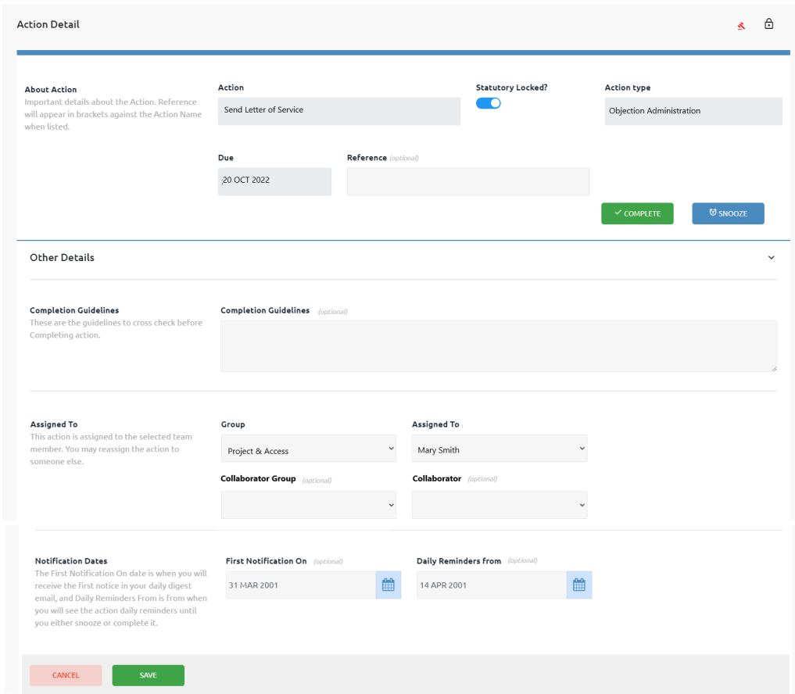

**Action** – description of the action required.

**Statutory Locked** – is the due date of the Action statutory and locked? Only the Administrator can amend the due date of a Statutory Locked action.

**Action Type** – group the action belongs to. The dropdown list of Action Types are managed via PX4 Studio as they are used in pathways and action templates for all areas within PX4.

**Due** – date the Action is due.

**Reference** – additional details describing the action. Will appear in brackets after the Action Name.

**COMPLETE** button – displays a popup for completion date, optional comment, and optional attach document.

**SNOOZE** button – snoozes the action from Daily Digest email and notifications until a Snooze End Date.

The following fields are hidden behind the ‘Other Details’ expandable section. To display, click on ‘Other Details’:

**Completion Guidelines** – optional additional instructions / check list before completing the Action.

**Group** – owner group for the Action.

**Assigned to** – User responsible for completing the Action and will receive notifications.

**Collaborator Group** – new feature for an optional Collaborator for the Action and will also receive notifications.

**Collaborator** – new feature for an optional Collaborator for the Action and will also receive notifications.

**First Notification On** –Required for the Daily Digest emails. The date is the first time the action will appear in the Daily Digest. If action manually created with no notification dates, the default timeframe for the Group will be used to calculate this date.

**Daily Reminder From** –Required for the Daily Digest emails. The date is the date the action will start to appear daily in the Daily Digest until it is completed. If action manually created with no notification dates, the default timeframe for the Group will be used to calculate this date.

**Triggers for Notification**

To Objection Manager

* Action updated by a User NOT the assigned Objection Manager.

To ‘Assigned To’ User

* Action updated by a User NOT the ‘Assigned To’ User.

Collaborator

* Action updated by a User NOT the Collaborator.

#### Update existing Create Action

Update existing Create Action (from Objections List, Hearings List, Communications List or Add dropdown on Header) screen to connect to new Objection and Communication entities, as well as assigning an optional Collaborator to the primary User. If a Collaborator is assigned to the Action as well, they will also receive all notifications.

The First Notification On date and Daily Reminder dates will be optional and will use the default timeframe for the Group to pre-calculate the dates when saved.

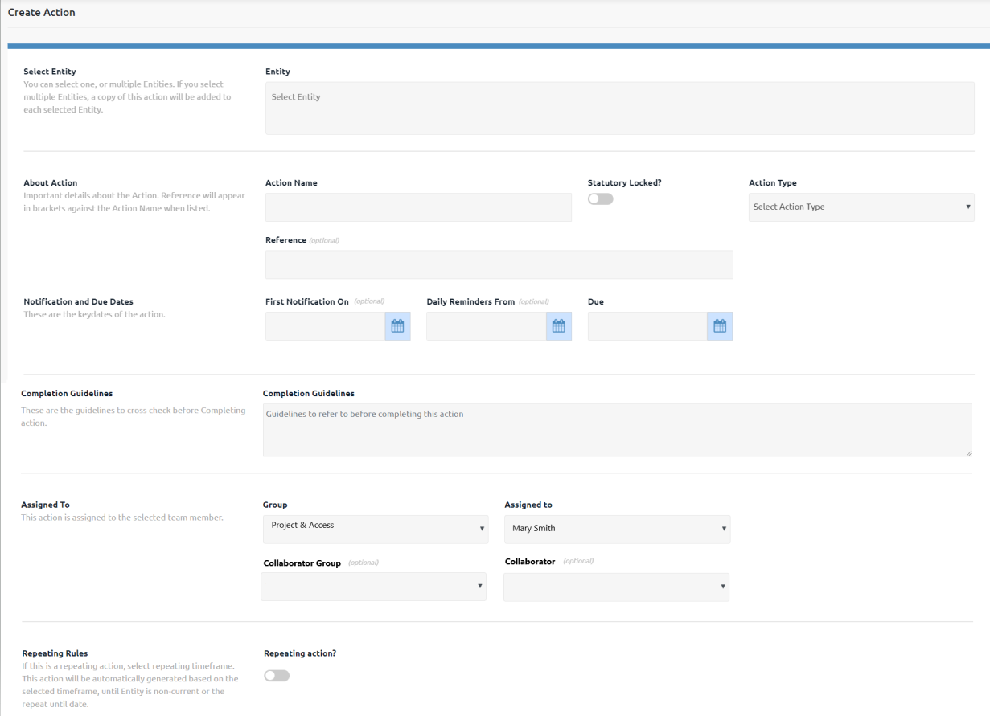

**Entity** – will be pre-filled with the Objection number this Action will be attached to.

**Action Name** – description of the action required.

**Statutory Locked** – is the due date of the Action statutory and locked? Only the Administrator can amend the due date of a Statutory Locked action.

**Action Type** – group the action belongs to. The dropdown list of Action Types are managed via PX4 Studio as they are used in pathways and action templates for all areas within PX4.

**Reference** – additional details describing the action. Will appear in brackets after the Action Name.

**First Notification On** – currently mandatory but will become optional. Required for the Daily Digest emails. The date is the first time the action will appear in the Daily Digest. The default timeframe for the Group will be used to pre-calculate this date.

**Daily Reminder From** – currently mandatory but will become optional. Required for the Daily Digest emails. The date is the date the action will start to appear daily in the Daily Digest until it is completed. The default timeframe for the Group will be used to pre-calculate this date.

**Due** – date the Action is due.

**Completion Guidelines** – optional additional instructions / check list before completing the Action.

**Group** – owner group for the Action.

**Assigned to** – User responsible for completing the Action and will receive notifications.

**Collaborator Group** – new feature for an optional Collaborator for the Action and will also receive notifications.

**Collaborator** – new feature for an optional Collaborator for the Action and will also receive notifications.

**Repeating action?** – does this Action repeat? If yes, record the repeating timeframe.

**Triggers for Notification**

To Objection Manager

* Action created by a User NOT the assigned Objection Manager.

To ‘Assigned To’ User

* Action created by a User NOT the ‘Assigned To’ User.

Collaborator

* Action created by a User NOT the Collaborator.

## ArcGIS Integration

The administrator will record the connection credentials required for using FMG’s spatial database.

### Objection Console

The new Objection Console will include a MAP card connecting to FMG’s spatial database, with an option to use TENGRAPH. The card will display the tenure boundaries of the Application as well as all Objection/s, showing the intersection.

We will research whether it is possible to display the tenure numbers as well.

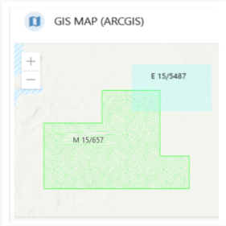

### Update existing Authority Console

Currently the Authority Console for WA Authorities, has a MAP card connecting to TENGRAPH displaying the boundary of the Authority.

This will be updated to connect to FMG’s spatial database instead, with an option to use TENGRAPH.

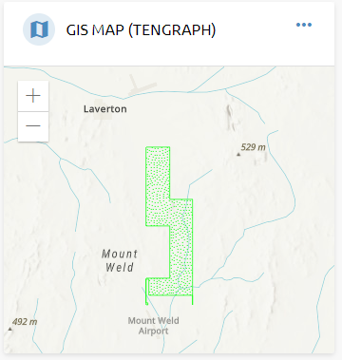

## Reporting

### Excel Download

Besides the existing download functions in PX4, the following new List screens will also have the ability to download the selected data into an Excel spreadsheet:

* Pre-Objection Assessments
* Objections
* Hearings
* Communications
* Master Activity (Meta Data) Log
* Department Audit
* Notifications Log.

### Standard Metric Graphs

We had proposed to create some common standard metric graphs within the Objections Module. Those graphs that most Users want to see and report on.

FMG currently output the following metric graphs:

1. **Month on month trending statistics**
2. Total objection count movement
3. Total increase/decrease of Incoming Objections
4. Total increase/decrease of Outgoing Objections
5. Average objection age in months.

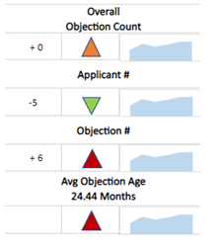

1. **Closed Objections Summary**
2. Closed Objections last 12 months, per Month (vertical bar chart)

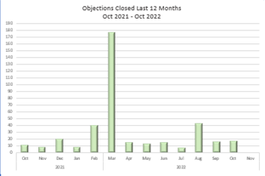

1. Closed Objections last 12 months, per Objection Type and Finalised Reason (pie chart)

1. Closed Objections last 3 months, per Month, per Objection Type (vertical bar chart)

1. Closed Objections, per Finalised Reason (Sankey chart)

1. **Current Objections Summary**
2. Active Objections, per Project (wheel chart)

1. Active Incoming Objections, per Objector (horizontal bar chart)

1. Active Outgoing Objections, per Applicant (horizontal bar chart)

1. Active Objections last 6 years, per Application Date Month (vertical bar chart)

1. Active Objections average age (years), per Project (horizontal bar chart)

1. Active Objections average age (months) and total objections for top 5 Projects (vertical bar chart)
   * Iron Bridge

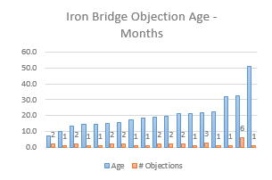

* + Chichester

* + Exploration/None

* + Solomon

* + PTP

1. **Total Objections Summary**
   1. All Objections, per Objection Lodged Date, filter Objection Lodged Date and Status Closed / Active (vertical bar chart)

As per Change Request CR-017, each graph of these graphs will take time and effort to develop within PX4.

### Custom Reporting

Another option is to spend the time and effort developing the integration with Tableau, which will allow FMG to create ANY metric / graph that you would like (embedded and linked within PX4), rather than building bespoke, static graphs, that are unable to be significantly modified with changing business needs and requirements.

## Document Library

### Document Library List



Currently, the Document Library is only viewable as a side menu option within each individual Entity.

There is no limit to the size of file that can be saved in the Document Library.

We will include Document Library on the Main Menu to display **ALL** documents currently saved for **ALL** entities, depending on User Permission.

We will also expand the Document record to also capture:

* Document date (defaulted to today’s date)
* Group Owner (defaulted to the User’s Group)
* Confidential to Group flag (defaulted to Yes)
* Optional internal hyperlink to existing Document Management System (DMS):
  + User could save the link to existing document instead of uploading to Document Library.

Via Change Request CR-015, the Document Library will be expanded to allow multiple documents to be saved at the same time at all points within PX4.

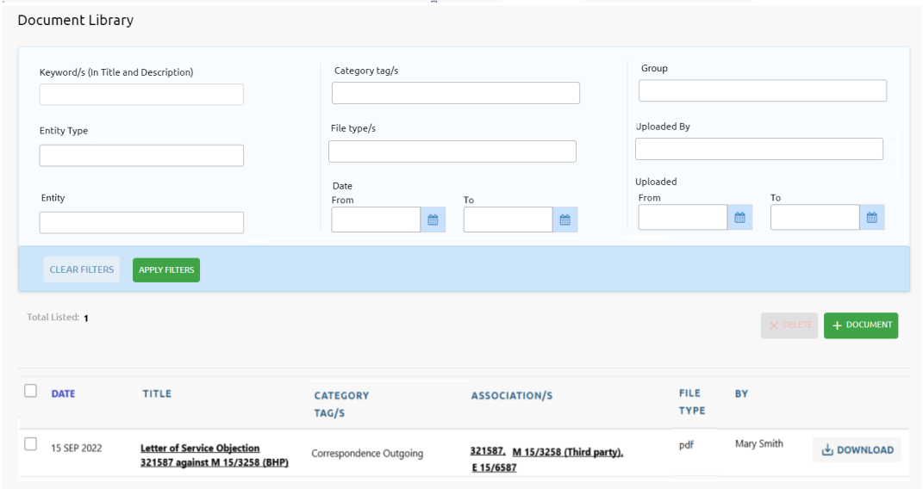

Filter option:

* **Keyword/s (in Title and Description)** – search the Title and Description of documents that includes these keywords.
* **Entity Type** – dropdown list of all entity types.
* **Entity** – dropdown list of all entity names.
* **Category Tag/s** – dropdown list of all Document Category Tags. Maintained within PX4 Studio.
* **File Type/s** – dropdown list of existing file types saved.
* **Date From/To** – document date either >= From date, or <= To date, or >= From date and <= To date
* **Group** – documents belonging to this Group/s
* **Uploaded By** – document uploaded by this User/s.
* **Uploaded Date From/To** – document uploaded date either >= From date, or <= To date, or >= From date and <= To date.

List columns:

* **Date** – document’s relevant date.
* **Title** – document’s short title. Hyperlinked to the Document Details screen.
* **Category Tag/s** – category/s for the document. There can be more than one.
* **Associations** – entity/s associated with this document. Hyperlinked to the entity’s Console.
* **File Type** – file extension for the document.
* **By** – who uploaded the document.
* **DOWNLOAD** button – download the document from the server to the client.

**DELETE** button – delete the selected documents.

**+ DOCUMENT** button – link to Attach Document popup to include a new document.

### Update existing Attach Document

Update:

* To include the new fields:
  + Date (default to today’s date)
  + Group Owner (default to the User’s Group)
  + Confidential to Group flag (default to Yes)
  + Internal Hyperlink, optional.
* Have the ability to attach multiple documents at the same time.
* Have the option to attach an actual file and/or save a hyperlink to a file already saved in an internal Document Management System.
  + If only saving the hyperlink, risk breaking the link if the file is moved.

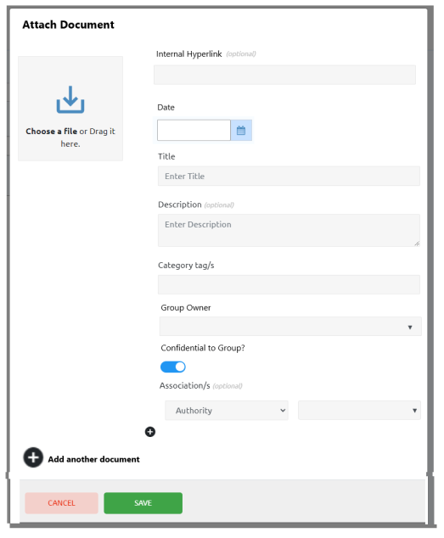

### Update existing Document Details

Update:

* to include the new fields
  + Date
  + Group Owner
  + Confidential to Group flag
  + Internal Hyperlink, optional
* if an internal hyperlink is saved, ability to click on the hyperlink to open the document.

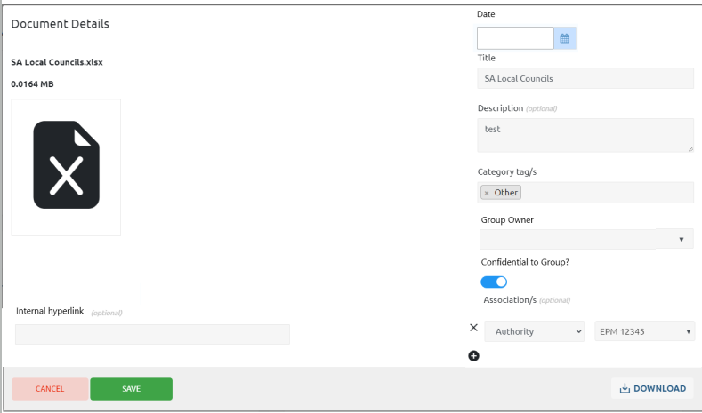

## Department Audit



A daily Department Audit process will compare pending and current WA Authorities in PX4 against the Tenement Gateway (which is updated with the current eMITS data every night), and report differences.

The User will have the option to **Apply, Acknowledge or Ignore** each reported difference.

On the Main Menu beside Department Audit will be the number of unprocessed records, as a quick visual.

For this Objections Module project, since tenement management actions are not applicable, initially the reported differences will only be relevant to Objections:

1. New FMG tenement application
   * FMG Stakeholders will be flagged in PX4 to identify them as FMG
   * Any new tenements in the Tenement Gateway with an FMG Stakeholder as the Holder will be automatically imported into PX4 as a ‘Managed’ Authority and reported to **Acknowledge**.
2. Change in Authority status
   * Any reported difference in a ‘Managed’ Authority status (pending, live, dead) cannot be directly applied because this is managed by a pathway. The related Authority Action will need to be completed to activate the next steps in the process to update the status. These differences will need to **Acknowledge**.
   * Any reported difference in a ‘Third Party’ Authority status will be automatically applied but will still be reported to **Acknowledge**.
3. Change in Authority ownership
   * Any reported difference in current Authority Holders will be reported to **Acknowledge**.
4. Change in Authority objection closing date
   * Any reported difference will be automatically applied but will still be reported to **Acknowledge**.
5. New Dealing
   * Any new Dealings against an Authority will be automatically saved but will still be reported to **Acknowledge**.
6. Change in Dealing
   * Any change to Dealings against an Authority will be automatically saved but will still be reported to **Acknowledge**.
7. New Objection within Dealings
   * Any new Objection Dealings against a Managed Authority will be automatically applied by creating an Objection record, initiating the pathway for an Incoming (intersecting tenure) and will be reported to **Acknowledge**.
   * Any new Objection Dealings against a Third-Party Authority will be reported to either **Apply** (if an FMG related objection to the Third-Party application) or **Ignore** (not related to FMG).
8. Change in Objection within Dealings
   * Any change to an Objection Dealing will be automatically applied by updating the Objection record and will be reported to **Acknowledge**.

If a difference has been reported and is still not processed, the difference will not be reported again not resulting in duplicates.

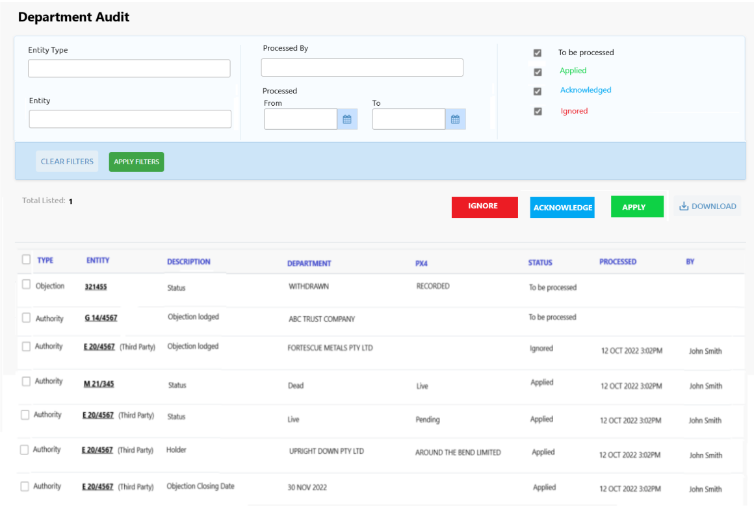

Filter options:

* **Entity Type** – dropdown list of all entity types
* **Entity** – dropdown list of all entity names
* **Processed by** – dropdown list of PX4 registered Users
* **Processed Date From/To** – processed date either >= From date, or <= To date, or >= From date and <= To date
* **Status** – audit record status.

List columns:

* **Type** – entity type
* **Entity** – entity name. Hyperlinked to the entity’s Console
* **Description** – audit description
* **Department** – value of the field within eMITS
* **PX4** – value of the field within PX4
* **Status** – current status of the audit record
* **Processed** – if the audit record has been Applied, Acknowledge or Ignored, when
* **By** -who processed the audit record.

**IGNORE** button – ignore the selected unprocessed audit records, because the PX4 value is the latest value, or it is not applicable.

**ACKNOWLEDGE** button – acknowledge the selected unprocessed audit records.

**APPLY** button – apply the department value to PX4 for the selected unprocessed audit records

**DOWNLOAD** button – download all selected audit records to Excel.

## Stakeholder Communications Module



Via Change Request CR-003, there is a requirement to track all stakeholder communications, record discussions and assign those discussions, record all Stakeholder Communications for future reference and how that piece of communication relates to other entities.

### Communication API

An API will need to be created to allow the various Communication related columns to be selected and filtered:

* Subject
* Category
* Type
* Start Date
* State Time
* End Date
* End Time
* Detail
* Status
* Stakeholders *(comma delimited if multiple)*
* Contacts *(comma delimited if multiple)*
* Authorities *(comma delimited if multiple)*
* Projects *(comma delimited if multiple)*
* Land Parcels *(comma delimited if multiple)*
* Agreements *(comma delimited if multiple)*
* Objections *(comma delimited if multiple)*
* Comments.

### Communication List

Since this is a new list screen to be developed, we will use the same flexible list format as the Objections List and Hearing List screens.

This new list format will allow the User to:

* Choose the columns they want to see
* Move those columns around
* Sort columns
* Filter data within the columns
* Set and re-set preference
* Pivot and charts
* Much, much more!

**ADD ACTION** button – ability to add an Action against the selected Communications. See Update existing Create Action section.

**ADD COMMENT** button – ability to add the same comment against the selected Communications.

**ADD DOCUMENT** button – ability to add Documents against the selected Communications. See Update existing Attach Document section.

**DOWNLOAD** button – ability to either download the columns currently displayed for selected Communications, download all data for selected Communications.

**UPDATE** button – ability to bulk update certain fields for the selected Communications. The fields that can be updated are:

* Status, including optional End Date/Time
* Category
* Type

### Communication Console

The Objection Console displays a summary of current objection relevant data on ‘cards’. The information is pulled directly from the database.

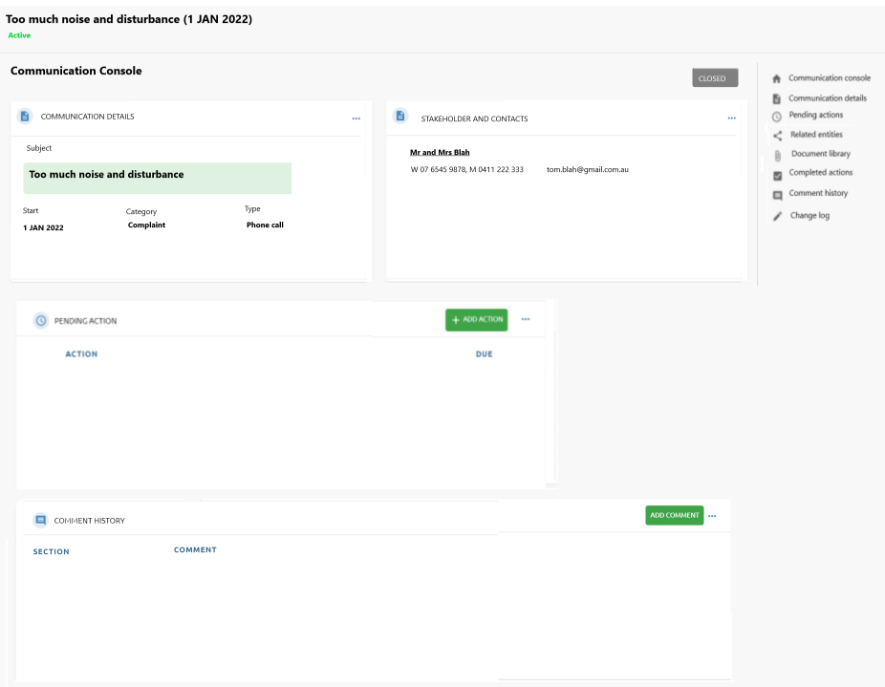

**COMMUNICATION DETAILS** card

* **Subject** –short description of the communication interaction (max 100 characters)
* **Start** –start date the communication was initiated
* **Category** –category of communication.List of valid Communication Categories are managed within the Administration Portal.
* **Type** – type of communication. List of valid Communication Types are managed within the Administration Portal.

**STAKEHOLDER AND CONTACTS** card

List of all Stakeholders and / or Contacts involved in the Communication interaction.

If Stakeholder

* **Stakeholder Name** – hyperlinked to Stakeholder Console

If Contact

* **Contact Name** – hyperlinked to Contact Console
* **Contact Details** – phone numbers and email address

**PENDING ACTIONS** card

For all Actions not yet completed for this Objection:

* **ACTION** – Action name
* **DUE** – due date
* **VIEW** button– link to Action Detail screen
* **ADD ACTION** button – link to blank Create Action screen to create one action against this Communication.
* **3 dots** – link to the Pending Actions screen.

**COMMENT HISTORY** card

For all comments saved against all sections for this Communication:

* **SECTION** – side menu section for the comment
* **COMMENT** – comment saved
* **ADD COMMENT** button – popup to create a comment against the Communication Details section for this Communication.
* **3 dots** – link to Comment History screen.

**CLOSED** button – will change the status of the Communication record to Closed and ask for the End Date and optional time.

### Create Communication

Click Add > Communication from the Header.

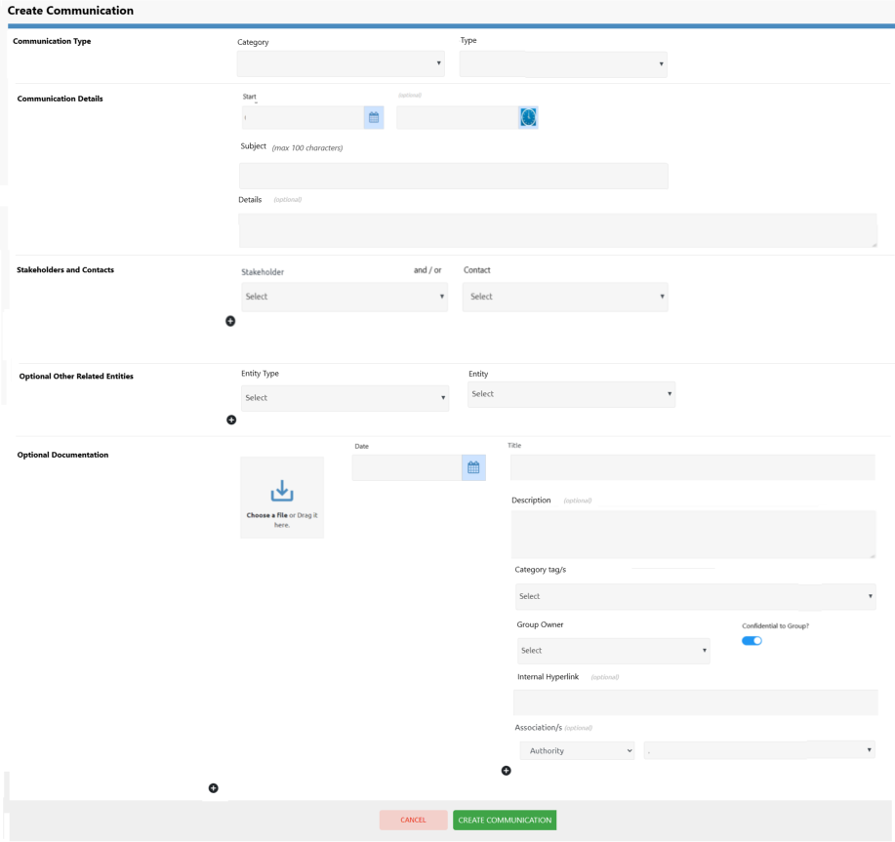

**Communication Category** – dropdown list of FMG managed Communication Categories (see Managed Lists)

**Communication Type** - dropdown list of FMG managed Communication Types (see Managed Lists)

**Start** – date the communication interaction was initiated. Optional time

**Subject** – short description of the communication interaction (max 100 characters)

**Details** – optional detailed description of the communication interaction

**Stakeholders and Contacts**

* At least one Stakeholder or Contact must be connected to the Communication
* If a Stakeholder is chosen, the dropdown list of Contacts will be for that Stakeholder
* If a Stakeholder is not chosen, the dropdown list of Contacts will be all Contacts

**Optional Other Related Entities**

* Other entities, besides Stakeholders and Contacts, that are related to this Communication
* **Entity Type** - dropdown list of all entity types (Authorities, Objections, Land Parcels, Projects, Agreements)
* **Entity** – dropdown list of entities for the chosen Entity Type

**Optional Document/s** – Attach one or more documents, which will be automatically associated with the Communication.

### Communication Detail

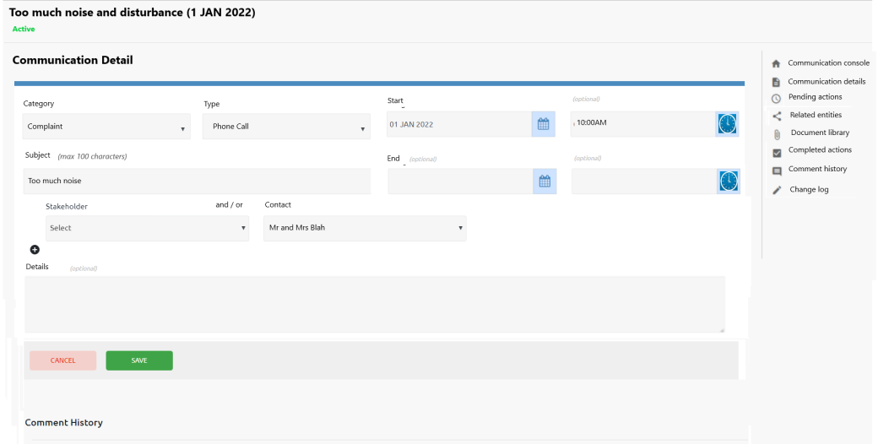

**Category** – dropdown list of FMG managed Communication Categories (see Managed Lists)

**Type** - dropdown list of FMG managed Communication Types (see Managed Lists)

**Start** – date the communication interaction was initiated. Optional time

**Subject** – short description of the communication interaction (max 100 characters)

**End** – optional date the communication interactions were closed. Optional time

**Stakeholders and Contacts**

* At least one Stakeholder or Contact must be connected to the Communication
* If a Stakeholder is chosen, the dropdown list of Contacts will be for that Stakeholder
* If a Stakeholder is not chosen, the dropdown list of Contacts will be all Contacts

**Details** – optional detailed description of the communication interaction

### Other Related Entities

Other entities, besides Stakeholders and Contacts, can be related to this Communication.

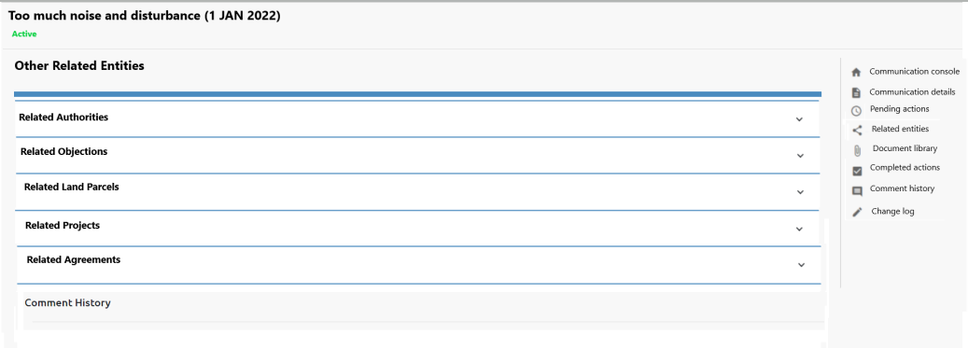

**Related Authorities**

* expandable section when you click on the section name
* list of any linked Authorities with the ability to remove links and add links to other Authorities
* Authorities will be hyperlinked to the Authority Console
* Each Authority Console will include a card and side menu option for Stakeholder Communications

**Related Objections**

* expandable section when you click on the section name
* list of any linked Objections with the ability to remove links and add links to other Objections
* Authorities will be hyperlinked to the Objection Console
* Each Objection Console will include a card and side menu option for Stakeholder Communications

**Related Land Parcels**

* expandable section when you click on the section name
* list of any linked Land Parcels with the ability to remove links and add links to other Land Parcels
* Authorities will be hyperlinked to the Land Parcel Console
* Each Land Parcel Console will include a card and side menu option for Stakeholder Communications

**Related Projects**

* expandable section when you click on the section name
* list of any linked Projects with the ability to remove links and add links to other Projects
* Authorities will be hyperlinked to the Project Console
* Each Project Console will include a card and side menu option for Stakeholder Communications

**Related Agreements**

* expandable section when you click on the section name
* list of any linked Agreements with the ability to remove links and add links to other Agreements
* Authorities will be hyperlinked to the Authority Console
* Each Agreement Console will include a card and side menu option for Stakeholder Communications

## Notification Log



Push notifications are short messages that appear within your browser and within PX4 to enable the User to take a specific action.

FMG have a requirement to use Push Notifications as a better form of communication rather than relying on emails, with all notifications logged.

Certain behaviour within PX4 will trigger a notification. These triggers are in priority order:

1. Pending statutory actions according to the notification time frame in escalation process, sent to the escalation User.
2. Pending statutory actions within notification time frame of their due date sent to the assigned responsible User.
3. New Third-Party Authority, Pre-Objection Assessment, Objection or Action record is created by someone other than the assigned responsible User to that entity or action, sent to the assigned responsible User.
4. Authority, Pre-Objection Assessment, Objection or Action is reassigned by someone other than the reassigned responsible User to that entity or action, sent to the reassigned responsible User.
5. Pre-Objection Assessment, Objection/Hearing or Action data is updated by someone other than the assigned responsible User to that entity or action, sent to the assigned responsible User.
6. A comment is made to Authority, Pre-Objection Assessment, Objection/Hearing or Action by someone other than the assigned responsible User to that entity or action, sent to the assigned responsible User.
7. @ tagged a PX4 registered User within comments, sent to the tagged User.

The updates can happen directly within the screens, or via a pathway step.

You want to be careful, you don’t have too many push notifications, otherwise it will become white noise and Users will not immediately respond as expected.

### Browser Notification

Depending on your device, browser, internal IT department protocols, operating system limitations and permissions, push notifications may not display in browser.

The notification recipient will need to be logged into PX4 in their browser to receive the notification.

### Notification List

Each notification triggered within PX4, will be logged and given an initial status of ‘Unread’. Each User will see on the notification icon on the Header, how many ‘Unread’ notifications they currently have.

When the User clicks on the notification icon, the Notification List screen will be displayed.

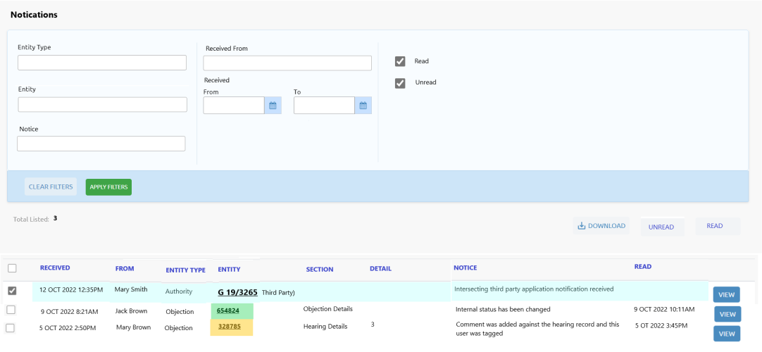

Filter options:

* **Entity Type** – dropdown list of all entity types
* **Entity** – dropdown list of all entity names
* **Notice** - search the Notification text that includes these keywords
* **Received From** – who triggered the notification
* **Received Date From/To** – notification received date either >= From date, or <= To date, or >= From date and <= To date
* **Status** – Read or Unread.

List columns (Unread notifications will be coloured and appear in priority order):

* **Received** – date and time the notification was triggered
* **From** – who triggered the notification
* **Entity Type** – entity type that triggered the notification
* **Entity** – entity that triggered the notification. Hyperlinked to the entity’s Console. If Objection, traffic light coloured according to the Objection Priority
* **Section** – which section within the entity triggered the notification
* **Detail** – if multiple records in the section, which detail record triggered the notification
* **Notice** – notification text
* **Read** – if Unread, this will be blank. If flagged as Read, this will be the date and time, the notification was flagged as Read
* **VIEW** button– navigates to the screen that triggered the notification.

**DOWNLOAD** button – downloads all notification data for the selected notifications into a spreadsheet.

**UNREAD** button – removes the Read date and time on selected Read notifications (in case accidentally flagged as Read)

**READ** button – flags the selected Unread notifications as Read and updating the date and time.

## Stakeholders



The new Objection entity will have relationships with various Stakeholders – applicants, objectors, external legal representatives, third party parent. When viewing the Stakeholder Console these relationships will be displayed.

### Update existing Stakeholder Console

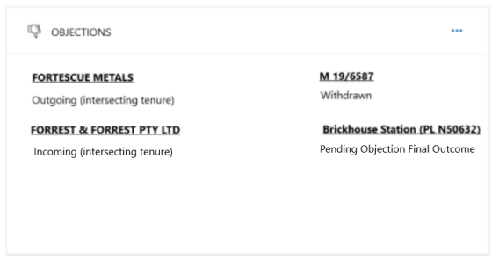

If the customer is subscribing to the Objections Module, the Stakeholder Console will display an Objections card summarising any Objections the Stakeholder is either an applicant or an objector, along with the type of objection and its current status.

### Update existing Stakeholder Detail

The Letter of Service form template includes an abbreviation for the applicant stakeholder. This abbreviation will need to be saved against the stakeholder in the Stakeholder Detail screen, so the Create Form generation can easily pull that data.

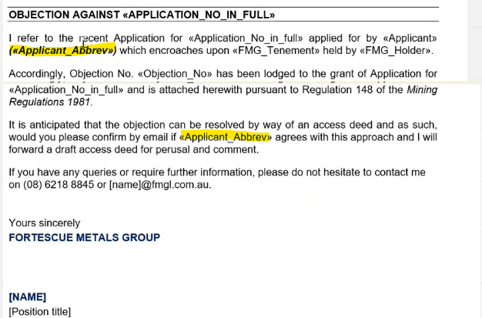

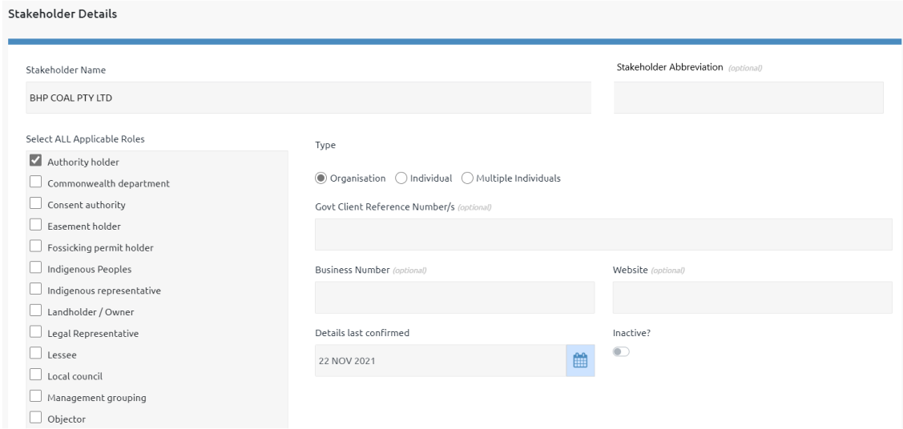

### Stakeholder Objections List

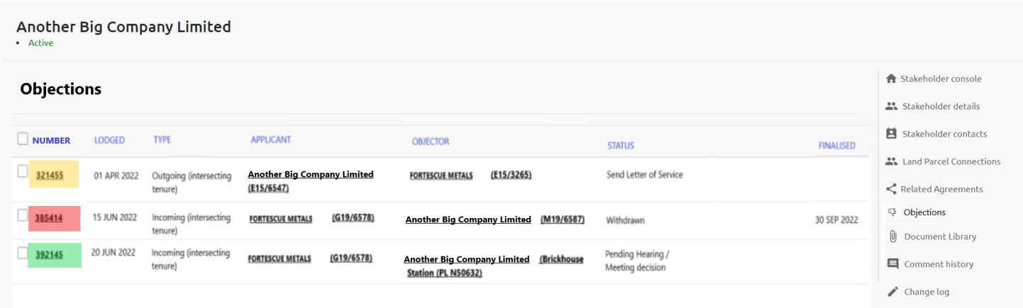

List of objections relating to this Stakeholder.

**Number** – objection number supplied by eMITS. Hyperlinked to the Objection Console.

**Lodged** – date the objection was lodged.

**Type** – type of objection.

**Applicant** – applicant and application subject to the objection. Applicant hyperlinked to the Stakeholder Console. Application hyperlinked to the Authority Console.

**Objector** – objector and authority objecting to the application. Objector hyperlinked to the Stakeholder Console. Authority hyperlinked to the Authority Console.

**Status** – current status of the objection, assigned by the pathway.

**Finalised** – date the objection was finalised.

## Agreements



The new Objection entity may result in an Agreement (eg Access Agreement) being negotiated and executed. When viewing the Agreement Console these relationships will be displayed.

### Update existing Agreement Console



If the customer is subscribing to the Objections Module, the Agreement Console will display an Objections card summarising any Objections the Agreement is related to, along with the type of objection and its current status.

### Agreement Objections List

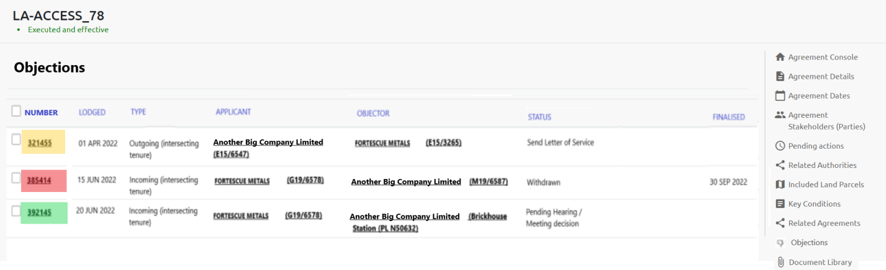

List of objections relating to this Agreement.

**Number** – objection number supplied by eMITS. Hyperlinked to the Objection Console.

**Lodged** – date the objection was lodged.

**Type** – type of objection.

**Applicant** – applicant and application subject to the objection. Applicant hyperlinked to the Stakeholder Console. Application hyperlinked to the Authority Console.

**Objector** – objector and authority objecting to the application. Objector hyperlinked to the Stakeholder Console. Authority hyperlinked to the Authority Console.

**Status** – current status of the objection, assigned by the pathway.

**Finalised** – date the objection was finalised.

## Private Cloud

Being a SaaS product, PX4 is currently operated as a multi-tenant application on a single cloud server. Multi-tenant SaaS implies the same URL is used to access a single instance of the software and its supporting technology being used by multiple customers. Our server and product is regularly penetration and security tested by a third party security company.

FMG has requested the use of their own separate private cloud server for improved security, but this comes with additional overheads in ongoing hosting, maintenance, and support costs. These costs will be absorbed in the Annual Licence Fee paid by FMG for ongoing use of the Objections Module and other PX4 Modules.